**

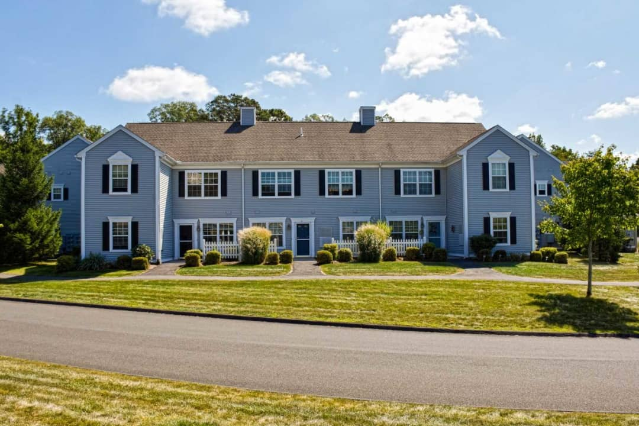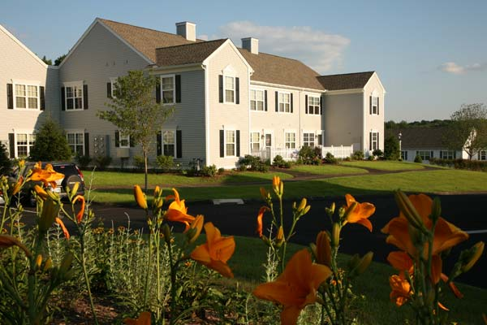

**4/8/22 Draft for Public Review**

**2022-2027 BERLIN**

**AFFORDABLE HOUSING PLAN**

**Affordable Housing Plan Leadership Team**

James Mahoney

Maureen Giusti

**Affordable Housing Committee Members**

George Millerd – Chairman

Robert Dombrowski – Vice Chairman

Ann Gamelin – Secretary

Amy Balko

Christopher Coppola

Tracy Shipman

Tracy Sisti

**Plan Document Prepared by:**

FHI Studio

Contents

Introduction 1

What is Affordable Housing? 2

The Plan Development Process 4

Community Values Statement 4

History of Affordable Housing in Berlin 5

Housing Needs Assessment 9

Land Use and Zoning Assessment 11

Land Use 11

Zoning 15

Plan Goals and Strategies 17

Plan Goal 17

Strategies 17

Strategy 1: Provide additional affordable home ownership opportunities. 17

Strategy 2: Provide more affordable housing for seniors. 17

Strategy 3: Refine existing Zoning Regulations to better support affordable housing. 18

Strategy 4: Maintain a focus on expanding affordable housing supply. 18

Implementation Plan 19

Glossary of Terms 21

Appendix 23

A1: Demographic Assessment 24

A2: Economic Indicators 29

A3: Housing Market Assessment 31

Rental Market 31

Ownership Market 32

CHFA Mortgage Market 33

A4: Gap Analysis 34

A5: Zoning Summary 38

A6: Berlin’s Multifamily Housing Inventory 44

A7: Survey Findings 46

# Introduction

Preparation of this Affordable Housing Plan was guided by a seven-member affordable housing plan advisory committee. The committee met regularly over a five-month period with Town staff and consultants to review data, discuss and implement outreach approaches and analyze findings, and develop the Community Values Statement and Implementation Plan components of this Plan.

Berlin has many homes that are selling at affordable prices. Information received from realtors and banks active in sale and financing of homes in Berlin regarding recent market conditions suggests that higher income buyers are purchasing most of the homes in the affordable price ranges because these buyers generally have an advantage over households with less than the median income because they can pay higher prices, offer larger down payments, and demand fewer contingencies. The affordability of homes in Berlin for households with less than the median income is not a supply issue, it seems to be a marketplace issue that would require creative long-term solutions such as revamping governmental programs for first time buyers to help them better compete or creating more affordable deed restricted homes. With the limited supply of affordable rental housing, households with less than the median income are also competing with higher income households for the available apartments. Price increases have accelerated for both sales prices and rents for housing in Berlin since the start of the COVID-19 pandemic. Also, construction costs for new housing have increased dramatically in this period. These trends have exacerbated the housing affordability problem.

Homelessness is a special housing issue. There is a relatively small number of homeless people in Berlin and the issue of homelessness appears to be a seasonal one. Dedicated governmental resources are needed to address this complex need.

The affordability of Berlin’s housing stock can also be considered in terms of persons that live and work in the community and in the region. Berlin is located within Greater Hartford, which is a highly urbanized area with a robust transportation network. Berlin also abuts the cities of New Britain, Meriden and Middletown that have significantly greater population and more diverse housing stocks than Berlin. There is significant mobility of persons living in the Greater Hartford region and only 11% of Berlin’s resident workforce is employed in Berlin and only 9% of Berlin jobs are filled by Berlin residents. Affordable housing is a regional issue and Berlin should continue to strive to increase its affordable housing stock to help address the regional affordable housing needs.

Clearly, affordable housing in the region, state and nation is a complex issue that will require a concerted, consistent, and long-term effort led by the state and federal governments. To contribute to this effort, Berlin will continue and expand its ongoing and productive efforts to increase the supply of affordable housing in the community consistent with its Community Values Statement. Berlin’s affordable housing efforts started in 1978 and 1982 with the building of the Marjorie Moore and Percival Heights senior apartment projects by the Berlin Housing Authority. From this base, the Town has substantially expanded its affordable housing stock by approving zoning revisions and supporting deed restricted senior, family, and mixed-income housing projects financed and assisted through the Connecticut Housing Finance Authority and the Connecticut Department of Housing. It has also approved projects that are not yet built that will add 178 units of housing that meet state affordable housing definitions. Applications are pending for projects that, if approved, would create about 42 more affordable rental units. Therefore, Berlin is well positioned to continue to create additional affordable housing in the community.

# What is Affordable Housing?

"Affordable housing" is defined or determined by State law and not by a personal opinion of what is affordable. Generally, Connecticut law encourages development of “affordable housing” priced so that households which earn 80% or less of the applicable median income (the lesser as between the state or area median income (AMI)), will spend no more than 30% of their annual income on housing.  Adjustments are made for the percentage of the applicable median income earned by the household, household size, housing type/unit size, etc.

Housing is deemed affordable per state statute if it is:

* Assisted housing receiving financial assistance under any governmental program for the construction or substantial rehabilitation of low and moderate income housing, and any housing occupied by persons receiving rental assistance under federal law.
* Financed by a Connecticut Housing Finance Authority mortgage.
* Subject to a deed recorded on the municipality’s land records containing a covenant or restriction requiring that it be sold or rented at, or below, prices which will preserve it as housing, for a defined period of time, for which persons and families pay 30% or less of income, where such income is less than or equal to 80% of the median income.
* Mobile manufactured homes located in resident-owned mobile manufactured home parks.

The charts below reflect actual rents and sales prices for affordable housing in Berlin based on area median income.

**Housing Affordability for Berlin’s Owner Households** (2019)

*Source: HUD 2021, ACS, RKG Associates   
*Income based upon average homeowner household size of 3 persons.*

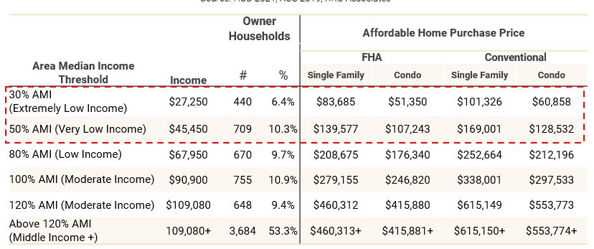

*

Based on an analysis by RKG Associates, 42% of Berlin’s ownership housing units are affordable to households with incomes between 50% and 100% of area median income (AMI) if financed with an FHA loan (FHA loans limit the purchase price of a home based upon income). The share of houses in Berlin that are affordable to that income bracket is 61% if financed with a conventional mortgage. Berlin has a sizeable share of households that have incomes above 120% of AMI that compete with lower income households for the same housing stocks. These households likely drive up the cost and reduce the available supply of housing that may otherwise be affordable to lower income households suggesting that the construction of new housing, even housing at upper price points, could make more housing available to households with lower incomes.

**Housing Affordability for Berlin’s Renter Households** (2019)

*Source: HUD 2021, ACS, RKG Associates   
*Income based upon average renter household size of 2 persons.*

*

Berlin has 849 low, very low, or extremely low-income households that comprise 66.5% of the Town’s renter households. The affordable monthly rents for these households range from $605 to $1,510 per month but there are not enough rental units priced in this range to meet the demand. Renter households in Berlin earning 100% or more of the AMI account for 33.5% of households. The affordable monthly rent for these households is $2,020 or above.

# The Plan Development Process

The Berlin Town Council created an Affordable Housing Plan Advisory Committee for the purpose of overseeing and offering input on the preparation of a Berlin Affordable Housing Plan for consideration and adoption by the Town Council. Since its creation in late 2021, the Affordable Housing Plan Advisory Committee has worked to prepare this Plan with the assistance of a consultant (FHI Studio), Town staff, and corporation counsel. The Committee conducted community outreach meetings (including a meeting at the Senior Center), and meetings with developers, realtors, banks, mortgage brokers, Town Departments, and the Central Connecticut Health District. The Committee also held joint meetings with the Plan of Conservation and Development subcommittee of the Planning and Zoning Commission.

To engage a wide audience in the plan development process, the Town conducted an online housing plan survey with physical copies of the survey made available at the Library, Senior Center, Town Hall, and upon request. The survey was launched in January of 2022 and remained open for approximately one month. In total, 766 people participated in the survey. Key survey responses include support for more senior affordable housing and affordable home ownership opportunities. The support for more senior affordable housing is consistent with the large proportion of the Town’s population that are 65 and over and the significant portion of that population that have very low or extremely low incomes. A complete analysis of survey results is included in the Appendices.

# Community Values Statement

Berlin is recognized as a historic and progressive Town with an engaged citizenry committed to the betterment of the entire community. We strive to provide high quality services to a diverse population living and working in a balanced blend of open space, residential housing, and commercial properties supported by stable and equitable revenues.

Berlin embraces a diverse and inclusive housing stock that provides affordable homeownership opportunities, quality rental options, and housing choices for all household types, income levels, and life stages. Berlin contains many unique neighborhoods ranging from rural areas with large lots and open space, to smaller lot single and two-family residential areas to condominiums to affordable apartment developments. Future housing development will continue to align with the unique characteristics of each area and neighborhood, in accordance with the Plan of Conservation and Development.

Berlin will continue to nurture a strong and diverse local economy retaining a vibrant manufacturing and commercial sector maintaining a good balance between its workforce and job opportunities in the community. Through a focus on economic development and fiscal responsibility, the Town maintains a low mill rate, which helps to maintain reasonable housing costs for all residents.

Finally, Berlin prides itself on its excellent quality of life for all residents, including its highly rated school system, quality Town services, farms and rural attributes, access to open space, community events like the Berlin Fair, and recreational opportunities. A diverse housing stock allows all residents to take advantage of what Berlin has to offer and ensures that existing residents can continue to live in the community as they age or as their life circumstances change.

# History of Affordable Housing in Berlin

Berlin’s share of affordable housing in 2021 was 9.02%, exceeding the statewide average by 3.1 percentage points. The Town’s share of affordable housing increased by 2 percentage points between 2011 and 2020. More substantial gains were experienced over the 19-year period between 2002 and 2020, with a 6.3 percentage point increase in the affordable share of the Town’s housing supply over that period. This increase in the supply of affordable housing is a result of intentional efforts by the Town over the past two decades to expand the supply of affordable housing in Berlin.

**Berlin’s Affordable Housing Supply** (Per 2021 Affordable Housing Appeals List)

|  |  |  |  |  |  |  |
| --- | --- | --- | --- | --- | --- | --- |
| 2010 Census Housing Unit Count | 2021 Gov Assisted | 2021 Tenant Rental Assistance | 2021 Single Family CHFA/USDA Mortgages | 2021 Deed Restricted Units | Total Assisted Units | 2021 Percent Affordable |
| 8,140 | 556 | 50 | 124 | 4 | 734 | 9.02% |

In 1978 the Berlin Housing Authority was established and the first affordable housing units in Berlin were constructed within the Marjorie Moore Village. In 1982 the Berlin Housing Authority completed the Percival Heights senior development. Affordable housing development activity resumed in the 2000’s with the development of three projects with a combination of age restricted mixed-income housing being constructed. Three additional projects added affordable units that were not age restricted in the 2010’s. Since 2020, multiple affordable units have been approved or have applications pending or expected.   
note to table – Deming Ridge is mixed income, not mixed use and is now under construction

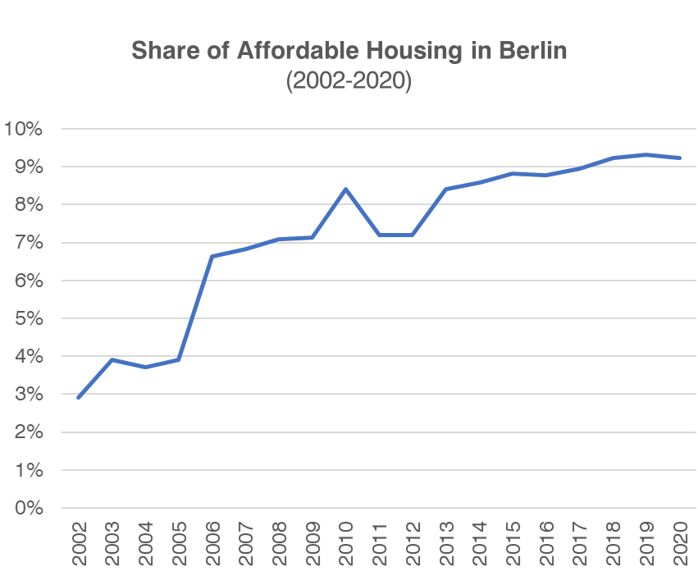

*Source: CT Department of Housing*

A significant amount of multi-family rental unit development has been approved, is under development, or has been built in Berlin within the past two decades. There are 560 existing apartments that count as affordable. In addition, approximately 530 units of multi-family rental residential units have been approved in Berlin since 2014, most in the last three years. Only 36 of the 530 approved units, including 4 affordable units, have been completed to date. There are 494 apartments, including 178 affordable units that are in the pipeline that have not yet been completed.

Built and approved developments include a mixture of market rate, mixed income, age restricted mixed income, and age restricted affordable apartments. Most of the Town’s existing affordable housing stock (423 0f 560 affordable units) was built between 2001 and 2013.

*Source: Town of Berlin*

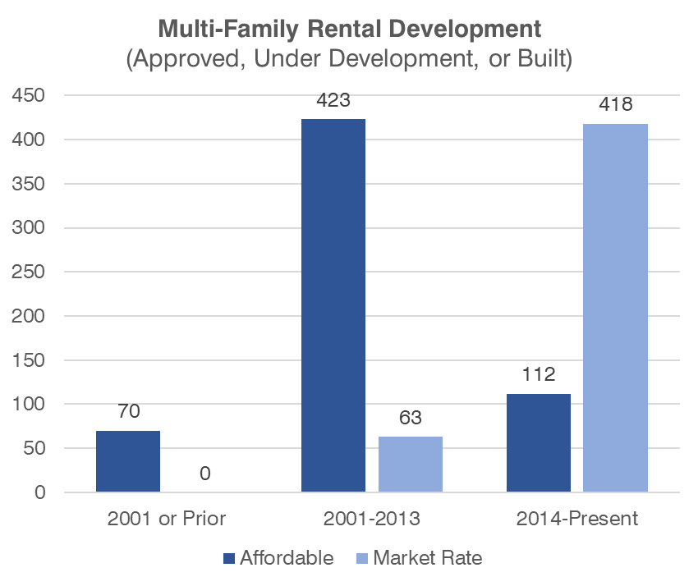

The Town is currently experiencing a rapid growth in applications for multi-family development projects in response to recent zoning amendments that have allowed multi-family residential development at new locations or at significantly higher densities as compared to what has been allowed historically in Town.

Below is a summary of recent Town and development activity:

* February 2015 - The Planning and Zoning Commission approved a 50-unit senior affordable rental project at 143 Percival Avenue for the Berlin Housing Authority.
* January of 2019 - The Berlin Planning and Zoning Commission approved an expansion of Core Area 1 in the Kensington Village Overlay Zone as well as an increase in permitted density in the Core Area 1 from 20 to 26 units per acre.
  + Steele Center, a mixed-use project with 76 units of market rate rental housing was approved in the Core Area 1 and the first building is under construction.
* May of 2019 - The Berlin Planning and Zoning Commission approved the creation of the Berlin Turnpike Development Zone (BTD).
  + A mixed-use project with 72 multi-family market rate units was approved in the BTD Zone at 196-250 Berlin Turnpike (Turnpike Ridge). The commercial portion of this mixed-use development has been completed.
  + A mixed-use project across three parcels in the BTD zone at 404 Berlin Turnpike was approved that would include 200 residential rental units. 80% of the units would be market rate and 20% deed restricted affordable.
  + An application is pending for a mixed-use project in the BTD zone at 550-554 Berlin Turnpike project that would include 106 residential rental units, 70% market rate and 30% affordable.
* August of 2020 - The Planning and Zoning Commission approved a zoning map and text amendment for Workforce Housing Development (WHD) at a site on Deming Road.
  + An 88-unit mixed income rental project was approved at this Deming Road site and construction of the project is underway.
* November 2021- The effective date of a Planning and Zoning Commission approved zoning amendment for planned residential in-fill housing development on the Berlin Turnpike for conversion of obsolete motels.
  + An application is pending for a 20-unit infill project at 1676 Berlin Turnpike that would include 4 affordable units.
* March 2022 – An application is pending for a 20-unit rental development with 4 affordable units at 309 Main Street, East Berlin in the Planned Office Residential Zone (POR).

A proposed zone change for a potential 300+ unit Rio Vista apartment rental project on Atkins Street was denied by the Planning and Zoning Commission and is now in an 8-30g appeal process. The trial court has ruled in the Commission’s favor and the applicant has a pending motion to reargue.

Berlin’s Zoning Regulations also provide for Neighborhood Affordable Housing Development (NAHD) in certain residential zones, including the R-43 Zone. For the R-43 zone (requiring a minimum lot size of 43,000 square feet), the minimum lot size in a NAHD is reduced to 15,000 square feet provided the average lot size is 21,000 square feet. The current affordability requirements for a NAHD require 30% of the houses to be deed restricted at the 80% median income level.

*Affordable, Age-Restricted, Mixed-Income, and Apartment Units in Berlin*

# Housing Needs Assessment

The inventory of vacant units that are for sale or for rent in Berlin is in a relatively unhealthy range. In 2019, there were 81 units listed as vacant for sale and 45 vacant for rent. This is out of a total housing stock of 8,584 units based on 2019 American Community Survey estimates.

*Source: American Community Survey*

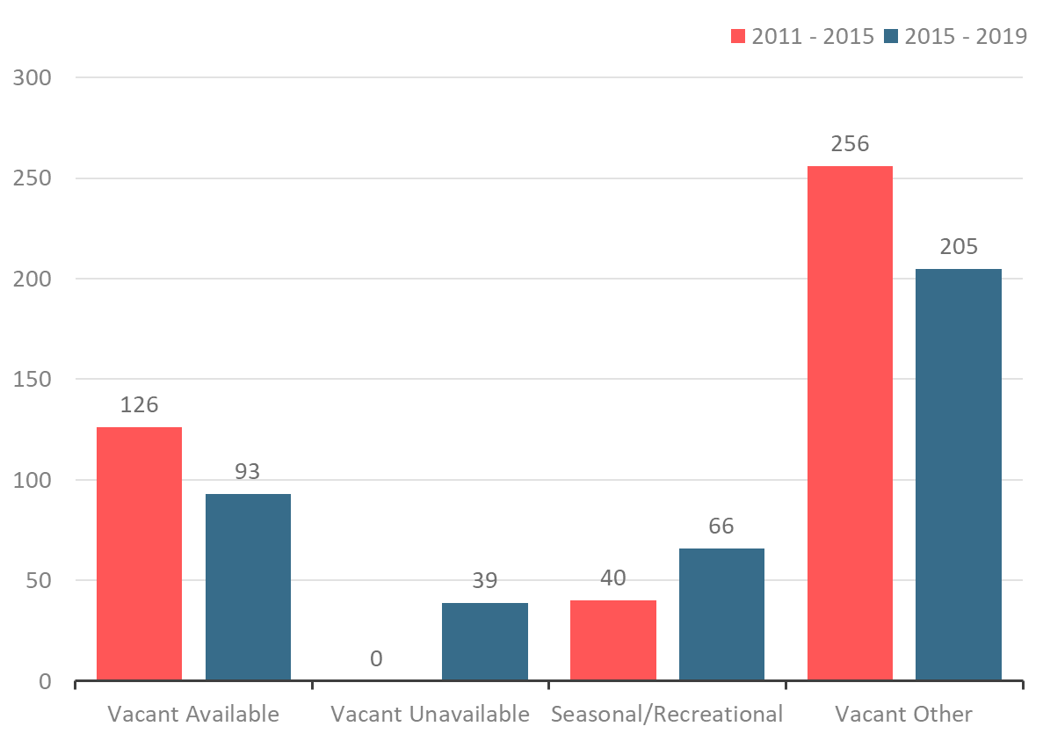

**Vacant Housing Units by Category (2011-2019)**



Connecticut State Population projections estimate that Berlin will add over 200 residents over the next two decades. The projections from the State do not reflect the recently approved, but not yet permitted residential units in Berlin. These units will add to the current housing stock which will help reduce some pressures on housing demand and are clearly responding to the strong market for rental housing we are seeing not only in Berlin, but across the United States.

While housing units have been added since 2010, housing permit activity over the past decade in Berlin has been at its lowest levels over the past 30 years. Permits for new housing construction have not rebounded but recently approved larger multi-family housing projects are expected to reverse this trend.

Single-family housing comprises 85.75% of Berlin’s residential land area but only comprises 28.5% of the Town’s total land area. The second largest portion of residential land area is condominiums which comprise 5.83% of residential land area and 1.93% of total land area. Single family homes and condos comprise the largest portion of residential units with 72% being single-family and 10% being condos. Residential development as a component of mixed use in other zoning districts is a growing share of the housing stock in Berlin.

In the case of Berlin, there are more potential buyers in the higher income brackets than there are housing units that match their maximum affordable housing prices . The maximum affordable home price for households earning below 50% of AMI is $139,577 with a FHA loan, and $169,001 with a conventional lending scenario. The difference between conventional loan and FHA affordable home prices results from a lower FHA down payment requirement which reduces the amount of debt a borrower can take on. The conventional mortgage option assumes a minimum 20 percent down payment. Only about 7% of the homes were valued below $175,000 in 2019, but 16.7% of the owner households earn at or below 50% of AMI (additional details on the housing gap are included in Appendix 5).

There is also a need for affordable rental housing in Berlin. About 45.1% of renter households, in addition to 16.7% of owner households as stated, earn less than 50% of the area median income (AMI), totaling 1,725 households. These households often experience housing instability, may rely on housing assistance, and typically spend more on housing as a percentage of their overall income than higher income households.

The rental supply is tight at both the lowest end and high end of the income spectrum. For extremely low-income renter households, the supply of affordable and available units is especially limited. There are 252 more households earning less than 30% of AMI than available affordably priced units with monthly gross rents at or below $605. Only 6.1% of occupied rental units have monthly rents below $605, while 25.6% of renter households earn at or below 30% of AMI. Units priced to households at or below 30% of AMI are typically provided by government organizations like housing authorities and non-profit affordable housing developers. These can also be provided using financial subsidies like housing vouchers.

Units priced between 50-100% of AMI account for 80% of all rental units, while only 40% of renter households have incomes corresponding to this price bracket. Hence, there are 505 units that are likely rented by households with lower incomes who are likely spending more than they should on housing costs.

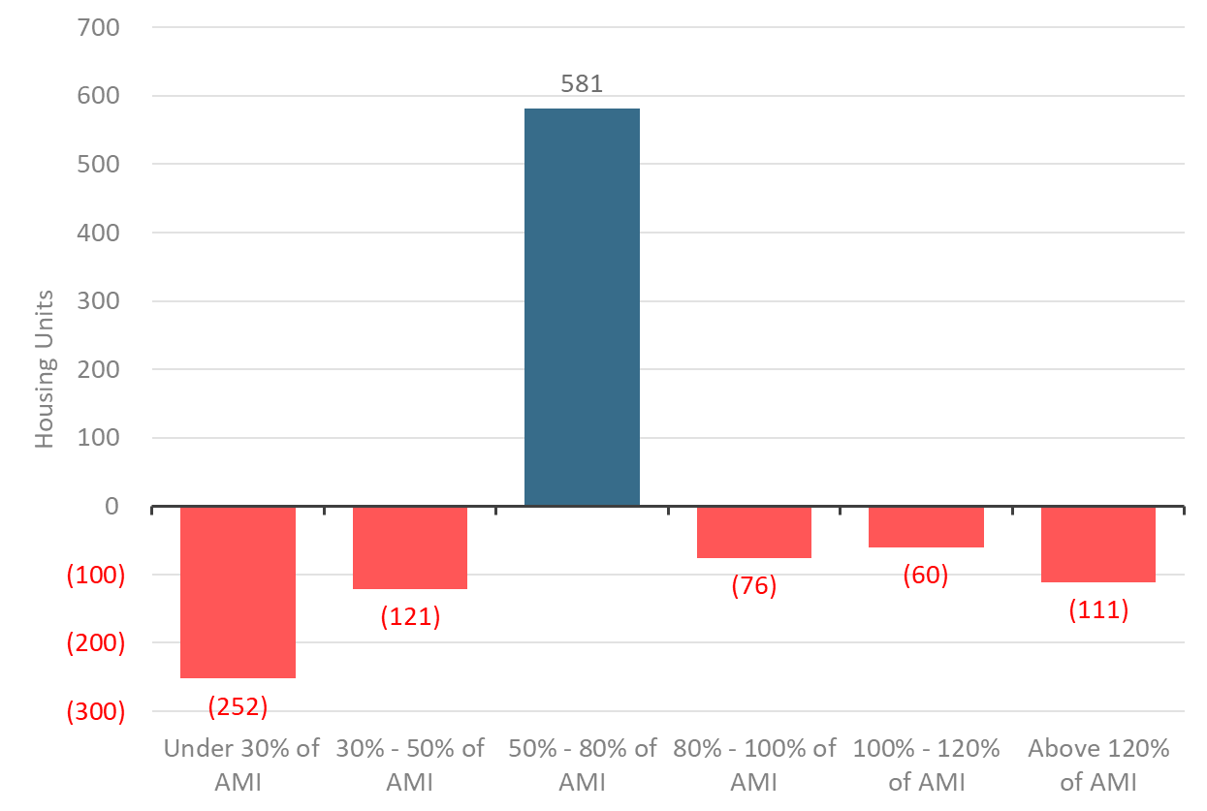

**Rental Supply and Demand Gap**(2019)

*Source: HUD, ACS*

Renter households earning more than 100% of AMI account for 16.9% of all households, but the supply of units at this price point accounts for only 3.6% of the rental stock. The gap between potential demand and actual supply for households above 100% AMI is 171 units. Some of this gap may be mitigated if and when the new approved multi-family rental developments are permitted, constructed, and occupied.

The lack of higher priced rental units in Berlin puts pressure on the supply of housing priced for lower income households. Higher income households have more choices in the housing market and are likely renting units at a lower price point than they can afford.

# Land Use and Zoning Assessment Note, Land Use and Housing Unit Type tables were removed. The tables are being updated for future inclusion in the Plan of Conservation and Development.

## Land Use

Berlin’s land use, based upon the primary land use of parcels, is predominantly public parks and open space and low density residential. High density residential uses represent 2% of Berlin’s area. High density residential uses are in limited areas and are primarily located in the northeast corner of Berlin, along the Berlin Turnpike, and in proximity to Kensington Center.

*Berlin’s Land Use*

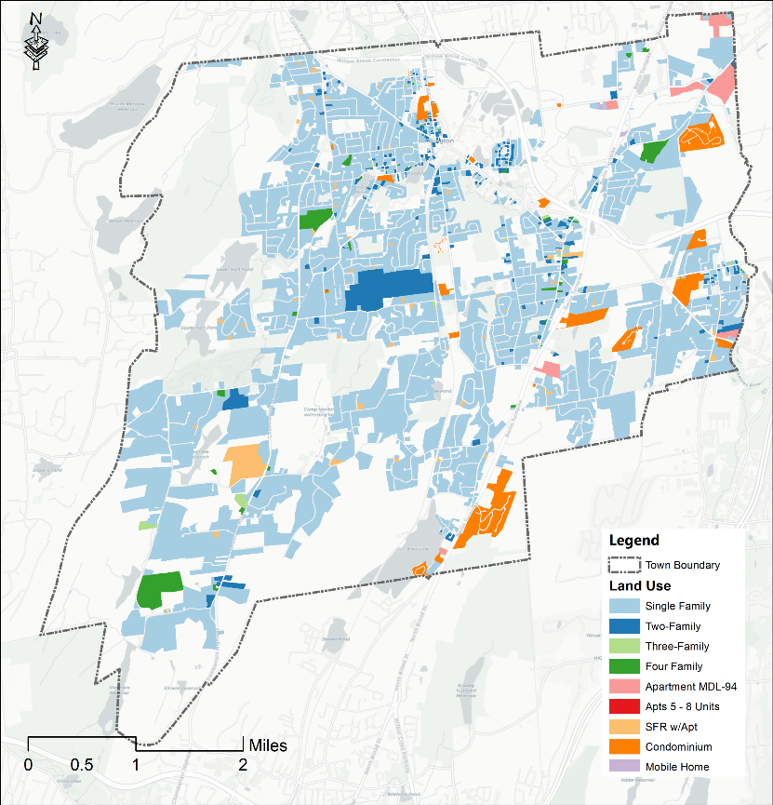

**Housing Unit Type**

*Housing Unit Type, Source: Town of Berlin, NE GEO, RKG Associates*

A build-out analysis of Berlin identifies a limited number of parcels that are available for residential development based upon the Town’s zoning districts and sewer service area. The map below shows developable parcels in green. Gray areas of the map are outside of the Town’s sewer service area. Many of the parcels identified as developable have wetland areas that are likely to limit development on the sites.

*Build Out Analysis*

## Zoning

Residential zoning is the most prevalent zoning type in Berlin. The share of residential zoning districts in the town (56%) exceeds residential land use (which totals 38%) by 18 percentage points. This is attributed to the fact that many parcels that are zoned for residential uses are undeveloped, and their land use is categorized as open space. Much of that open space is deed-restricted open space held by the Town or State or is water company land.

Berlin permits residential development in a range of districts in addition to its residential zoning districts. Of the districts that permit residential development,

* 11 districts permit low density multifamily development (4 units per acre or less)
* 6 districts permit high density multifamily development (more than 4 units per acre)
* 1 district provides a density bonus for the development of affordable housing, note regarding map, BTD zone change for 404 Berlin Tpke was approved so map was updated
* 3 districts allow affordable housing single-family developments
* 3 districts allow adult housing development
* 4 districts allow Berlin Housing Authority elderly housing
* **Map

  Description automatically generated**5 districts allow accessory dwelling units

***Districts Allowing High Density Residential***

Zoning Districts that allow multifamily residential development greater than 4 units per acre.

**Zoning Considerations for Affordable Housing Development**

* Multi-family developments are allowed in multiple districts, subject to special permit review and criteria.
* Higher density multifamily development is allowed in targeted geographic areas.
* There are specific criteria that allow an ADU (define ADU) through a special permit process.
* The PDD district does not provide specifications for any allowable uses.
* Many affordable and multifamily units developed in earlier periods are age restricted and only available to those age 55 and older but no projects approved since 2015 are age restricted.
* Multifamily unit size or bedroom count can affect the availability of affordable housing options for families.
* Some deed restrictions for housing built as affordable have expired or will sunset soon.

# Plan Goals and Strategies

Berlin has made significant progress on the creation of affordable housing and has many additional affordable units already in the pipeline. Based on the status of its affordable housing creation efforts, an analysis of housing data, the input provided by community surveys and outreach and an understanding of its role in the intergovernmental effort to provide affordable housing, the Town will focus its efforts on:

* Increasing housing for low and very low-income seniors
* Providing affordable home ownership opportunities, and
* Continuing to take advantage of its designation as a State high opportunity area to consider additional affordable housing projects, with a preference for mixed-income projects at targeted locations including the Berlin Transit Oriented Development area near the Berlin Train Station.

Achieve the development of additional affordable housing units in Berlin that will meet the needs of all Town residents and will result in a total share of affordable housing that exceeds ten percent of the Town’s total housing supply.

## Plan Goal

## Strategies

Four strategies are identified below as a means of achieving the plan goal.

### Strategy 1: Provide additional affordable home ownership opportunities.

Actions:

* Explore partnerships with organizations such as Habitat for Humanity to construct affordable home ownership units.
* Evaluate Town land that could be made available for the creation of affordable home ownership opportunities (excluding properties, or areas of properties, that were purchased for conservation or are an important open space asset).
* Evaluate zoning strategies that would facilitate the creation of deed restricted affordable homes (e.g. review existing Neighborhood Affordable Housing Development Zoning Regulations to encourage the use of this zoning tool).
* Evaluate whether financial incentives (e.g., tax abatements and others) should be developed to further create affordable home ownership opportunities.

### Strategy 2: Provide more affordable housing for seniors.

Actions:

* Continue to support the Berlin Housing Authority project approved by the Planning and Zoning Commission to build 50 units of low and very low-income senior rental housing at 143 Percival Avenue. The Town has an option to sell that site to the Berlin Housing Authority for $1 to support the project.
* Evaluate adding other organizations to the provision in the Zoning Regulations that allows the Berlin Housing Authority to build elderly housing in single-family residential zones by special permit.
* Ensure that universal design features (standards ensuring homes are accessible for those with mobility limitations and other disabilities) are incorporated into all new multifamily housing structures by requiring a percentage of units be constructed with these features.
* Proactively lobby State and Federal representatives to help secure funding for affordable housing initiatives in Berlin.

### Strategy 3: Refine existing Zoning Regulations to better support affordable housing.

Actions:

* Review residential zoning districts for opportunities to add additional housing types that may not be allowed today (i.e. two-family homes/duplexes).
* Evaluate allowing mixed-use development with affordable housing in potential redevelopment areas at Webster Square and Ferndale Plaza areas.
* Review BTD zoning to ensure that the regulations adequately support the development of affordable housing.
* Evaluate allowing greater densities in the Kensington Village Core 2 overlay district with the addition of a requirement that developments include an affordable component.
* Consider offering local incentives, including tax abatement, for affordable housing projects.
* Evaluate potential changes to the Accessory Dwelling Unit (ADU) provisions of the Zoning Ordinance to expand the use of ADU’s in meeting housing needs.
* Evaluate potential changes to the PDD district to provide specifications for affordable housing uses.
* Evaluate requirements for bedroom counts and unit sizes for affordable rental units.

### Strategy 4: Maintain a focus on expanding the affordable housing supply.

Actions:

* Review and recommend actions to diversify the Town’s housing stock as part of the Town’s ongoing 2023 update to its Plan of Conservation and Development and subsequent POCD implementation plan.
* Establish a Plan of Conservation and Development Implementation Committee to track Plan Implementation especially with respect to housing diversification and affordability.
* Maintain adequate Town staffing and skill sets to administer affordable housing programs.
* Offer Affordable Housing training to staff and members of land use boards.
* Continue to require and monitor affordable housing implementation plans for all projects that include an affordable housing component.
* Continue tax incentives for mixed-use, inclusionary projects.
* Develop a public education campaign in town to communicate the need for affordable housing and discuss the need and benefits of housing across all types and income spectrums. Discuss and present housing as an economic development tool in Berlin.
* Prioritize the creation of affordable housing for households at less than 50% of AMI.
* Explore extending the required duration of deed restrictions beyond 40 years or make them permanent.
* Communicate with affordable housing developers about opportunities for affordable housing development in Berlin.
* Explore the potential for creating affordability deed restrictions for portions of the existing housing stock.

# Implementation Plan

The following implementation plan summarizes the strategies and action items identified in the preceding section. This plan identifies the timeframe of actions and the responsible party for initiating those actions.

|  |  |  |  |
| --- | --- | --- | --- |
| Strategy | Action | Timeframe | Responsible Party |
| 1) Provide additional affordable home ownership opportunities. | 1.1) Explore partnerships with organizations such as Habitat for Humanity to construct affordable home ownership units. | Ongoing | Town Manager |
| 1.2) Evaluate Town land that could be made available for the creation of affordable home ownership opportunities (excluding properties, or areas of properties, that were purchased for conservation or are an important open space asset). | 2022 | Town Manager |
| 1.3) Evaluate zoning strategies that would facilitate the creation of deed restricted affordable homes (e.g., review existing Neighborhood Affordable Housing Development Zoning Regulations to encourage the use of this zoning tool). | 2023 | Planning & Zoning Commission |
| 1.4) Evaluate whether financial incentives (e.g., tax abatements and others) should be developed to further create affordable home ownership opportunities. | 2023 | Town Manager |
| 2) Provide more affordable housing for seniors. | 2.1) Continue to support the Berlin Housing Authority project approved by the Planning and Zoning Commission to build 50 units of low and very low-income senior rental housing at 143 Percival Avenue. The Town has an option to sell that site to the Berlin Housing Authority for $1 to support the project. | Ongoing | Town Manager |
| 2.2) Evaluate adding other organizations to the provision in the Zoning Regulations that allows the Berlin Housing Authority to build elderly housing in single-family residential zones by special permit. | 2023 | Planning & Zoning Commission |
| 2.3) Ensure that universal design features (standards ensuring homes are accessible for those with mobility limitations and other disabilities) are incorporated into all new multifamily housing structures by requiring a percentage of units be constructed with these features. | 2024 | Planning & Zoning Commission |
| 2.4) Proactively lobby State and Federal representatives to help secure funding for affordable housing initiatives in Berlin. | Ongoing | Town Council |
| 3) Refine existing Zoning Regulations to better support affordable housing.  3) Refine existing Zoning Regulations to better support affordable housing. | 3.1) Review residential zoning districts for opportunities to add additional housing types that may not be allowed today (i.e. two-family homes/duplexes). | 2023 | Planning & Zoning Commission |
| 3.2) Evaluate allowing mixed-use development with affordable housing in potential redevelopment areas at Webster Square and Ferndale Plaza areas. | 2023 | Planning & Zoning Commission |
| 3.3) Review BTD zoning to ensure that the regulations adequately support the development of affordable housing. | 2023 | Planning & Zoning Commission |
| 3.4) Evaluate allowing greater densities in the Kensington Village Core 2 overlay district with the addition of a requirement that developments include affordable components. | 2022 | Planning & Zoning Commission |
| 3.5) Consider offering local incentives, including tax abatement, for affordable housing projects. | 2023 | Town Manager |
| 3.6) Evaluate potential changes to the Accessory Dwelling Unit (ADU) provisions of the Zoning Ordinance to expand the use of ADU’s in meeting housing needs. | 2022 | Planning & Zoning Commission |
| 3.7) Evaluate potential changes to the PDD district to provide specifications for affordable housing uses. | 2024 | Planning & Zoning Commission |
| 3.8) Evaluate requirements for bedroom counts and unit sizes for affordable rental units. | 2023 | Planning & Zoning Commission |
| 4) Maintain a focus on expanding the affordable housing supply. | 4.1) Review and recommend actions to diversify the Town’s housing stock as part of the Town’s ongoing 2023 update to its Plan of Conservation and Development and subsequent POCD implementation plan. | 2023 | Planning & Zoning Commission |
| 4.2) Establish a Plan of Conservation and Development Implementation Committee to track Plan Implementation especially with respect to housing diversification and affordability. | 2023 | Town Council, Town Manager will track implementation until the Committee is formed |
| 4.3) Maintain adequate Town staffing and skill sets to administer affordable housing programs. | Ongoing | Town Council |
| 4.4) Offer Affordable Housing training to staff and members of land use boards. | Ongoing | Town Manager |
| 4.5) Continue to require and monitor affordable housing implementation plans for all projects that include an affordable housing component. | Ongoing | Planning & Zoning Commission, Community Services |
| 4.6) Continue tax incentives for mixed-use, inclusionary projects. | Ongoing | Town Council |
| 4.7) Develop a public education campaign in town to communicate the need for affordable housing and discuss the need and benefits of housing across all types and income spectrums. Discuss and present housing as an economic development tool in Berlin. | 2023 | Economic Development Commission |
| 4.8) Prioritize the creation of affordable housing for households at less than 50% of AMI. | Ongoing | Planning & Zoning Commission |
| 4.9) Explore extending the required duration of deed restrictions beyond 40 years or make them permanent. | 2023 | Planning & Zoning Commission |
| 4.10) Communicate with affordable housing developers about opportunities for affordable housing development in Berlin. | Ongoing | Economic Development Commission |
| 4.11) Explore the potential for creating affordability deed restrictions for portions of the existing housing stock. | 2025 | Town Manager |

# Glossary of Terms

**Accessory Apartment or Unit:** As per C.G.S. 8-1a(b)(1), a separate dwelling unit that:

* is located on the same lot as a principal dwelling unit of greater square footage,
* has cooking facilities, and
* complies with or is otherwise exempt from any applicable building code, fire code and health and safety regulations.

**ACS:** American Community Survey.

**Affordable Accessory Apartment:** As per C.G.S. 8-1a(b)(2), an accessory apartment that is subject to binding recorded deeds which contain covenants or restrictions that require such accessory apartment be sold or rented at, or below, prices that will preserve the unit as housing for which, for a period of not less than ten years, persons and families pay thirty per cent or less of income, where such income is less than or equal to eighty per cent of the median income.

**Affordable Housing:** As used in C.G.S. Section 8-30g, housing (including utilities) that costs less than 30% of annual income for households earning 80% or less of Area Median Income. Adjustments are made for the percentage of the applicable median income earned by the household, household size, housing type/unit size, etc.

Housing is deemed affordable per state statute if it is:

* Assisted housing receiving financial assistance under any governmental program for the construction or substantial rehabilitation of low and moderate income housing, and any housing occupied by persons receiving rental assistance under federal law.
* Financed by a Connecticut Housing Finance Authority mortgage.
* Subject to a deed recorded on the municipality’s land records containing a covenant or restriction requiring it be sold or rented at, or below, prices which will preserve it as housing, for a defined period of time, for which persons and families pay 30% or less of income, where such income is less than or equal to 80% of the median income.
* Mobile manufactured homes located in resident-owned mobile manufactured home parks.

**Age Restricted Housing:** Housing that is occupancy restricted by age, typically 55 years of age or older.

**Area Median Income (AMI):** The midpoint of a region’s annual income (meaning half of the households in the region earn more than the median and half earn less than the median) as determined by HUD which is used to calculate eligibility for certain affordable housing programs.

**Assisted Housing:** As used in C.G.S. Section 8-30g, housing which is receiving, or will receive, financial assistance under any governmental program for the construction or substantial rehabilitation of low- and moderate-income housing, and any housing occupied by persons receiving rental assistance.

CHAS – add definition

**C.G.S.:** Connecticut General Statutes

**C.G.S. Section 8-30g:** A reference to the Affordable Housing Appeals Procedure established by the State of Connecticut.

CT DECD – Connecticut Department of Economic and Community Development.

**Household:** All the people who occupy a housing unit.

**HUD:** The United States Department of Housing and Urban Development.

**Inclusionary Zoning:** Municipal regulations which make some provision for housing affordable to people with low to moderate incomes as part of new development approvals – either in terms of establishment of units, a fee-in-lieu-of units, and/or other approaches. Programs can be mandatory (required) or voluntary (incentivized).

**Market Rate Housing:** Housing that is priced within ranges as determined by housing market conditions without price restrictions or subsidy.

**Median Income:** As used in C.G.S. Section 8-30g, after adjustments for family size, the lesser of the state median income or the AMI for the area in which the municipality containing the affordable housing development is located, as determined by HUD.

**Mixed Income Housing:** Housing that is comprised of a mixture of market-rate and affordable housing units.

**Mixed-Use Development:** Development containing both residential and nonresidential, commercial or business uses.

**Single-Family:** A detached structure that consists of one dwelling unit.

**Townhouse:** As per C.G.S. 8-1a(b)(7), a residential building constructed in a grouping of three or more attached units, each of which shares at least one common wall with an adjacent unit and has exterior walls on at least two sides. Generally, a unit placed side-by-side with other units within a multi-unit structure and having no other units above or below.

**Two-Family:** A detached structure that consists of two dwelling units.

**Universal Design:** Universal design is design that is accessible to people with a wide range of abilities, disabilities, and other characteristics. As applied to housing, universal design is associated primarily with American with Disabilities Act compliant design and construction.

# Appendix

A1: Demographic Assessment

A2: Economic Indicators

A3: Housing Market Assessment

A4: Gap Analysis

A5: Zoning Summary

A6: Multifamily Housing Inventory

A7: Survey Findings

*Note: The data referenced in this plan and provided in the following appendix was obtained from multiple sources and databases as available to the project team. This includes data from the US Census Bureau, the Department of Housing and Urban Development (HUD), the State of Connecticut, and private data sources such as Redfin, Zillow, and Zumper. As such, there is variance between datasets. Regardless of variance between sources, this data has been a useful tool in providing a rational basis for many of the recommendations of this plan.*

# A1: Demographic Assessment

Berlin’s population grew at a steady rate in the 30 years between 1980 and 2010, but growth has slowed since 2010. Population growth generally places pressure on housing supply, increasing demand and often increasing housing rental cost and purchase prices. Berlin has experienced most of its population growth in age cohorts 60 and older. These households are smaller in size than younger households which implies that Berlin’s housing stock is accommodating fewer people. Combined with population growth, an aging population with fewer persons per household increases housing demand and places upward pressure on housing costs.

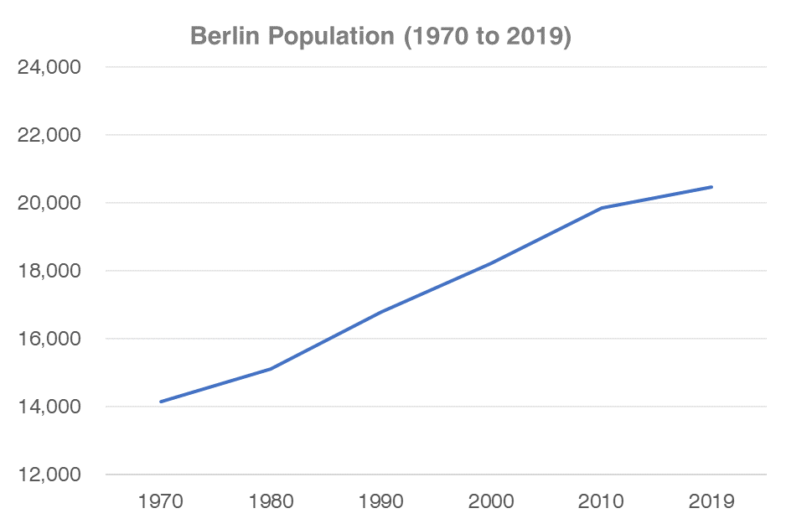

*Source: US Census and American Community Survey*

According to population projections conducted by the State of Connecticut, Berlin’s population is expected to continue to grow over the next decade, although modestly (by approximately 200 residents). Population is expected to peak in 2030 at 20,468 and according to projections will recede from those levels following 2030. These projections do not account for either the population shifts attributed to COVID-19 or the significant recent increase in approved, but yet unbuilt, apartments.

**Total Population Change (2010-2040, Town of Berlin)**

*Source: CT State Data Center, ACS 5-Year Estimates*

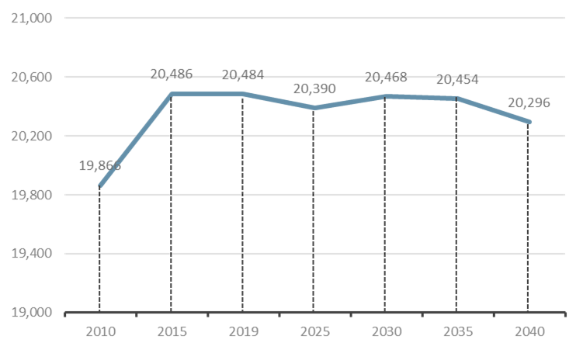

Berlin is less racially and ethnically diverse than the State and Hartford County and has a smaller share of residents with less than “very well” English proficiency. Between 2010 and 2019, the Town’s population has remained relatively stable but the racial and ethnic composition of residents has shifted. In 2019, fewer residents identify as White only, and more residents identify as Black or African American, Asian American, and those who identify as Some Other Race.

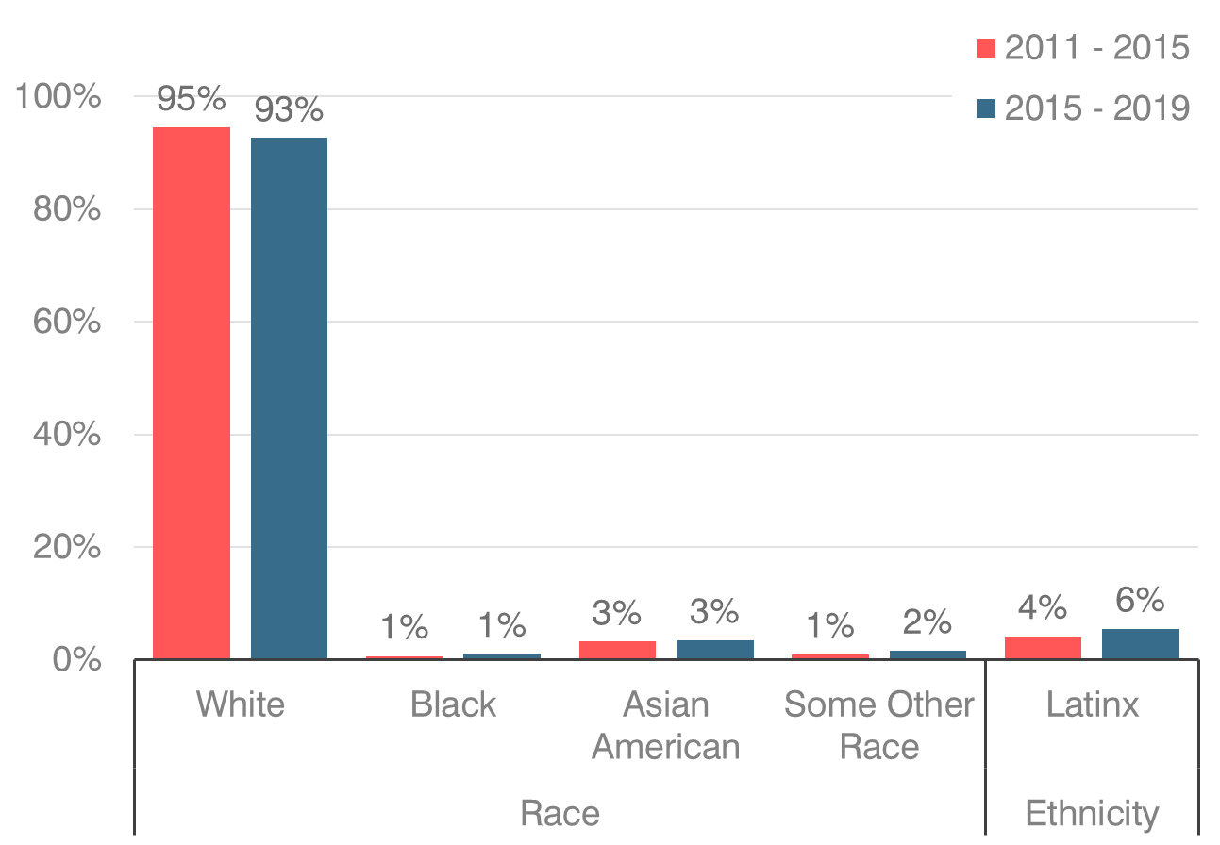

**Population by Race/Ethnicity**

*Source: American Community Survey*

*Source: US Census and American Community Survey*

**Household Size (2000-2018)**

Over this time, there was a significant gain in residents who identify as Latinx. Residents identifying with this ethnicity increased 32%, or a gain of about 274 people. Berlin also saw an increase of 128 residents identifying as “Some Other Race”. In many communities across Connecticut and the United States, demographic trends are very similar with many communities seeing an increase in residents who identify as Latinx and those who are identifying as Some Other Race. The percentage of Black and African American residents, as well as Asian American residents experienced increases of 52% and 8%, respectively.

The average household size in Berlin declined from 2.67 to 2.48 between 2000 and 2018. Household size in both Hartford County and the State increased slightly over that period.

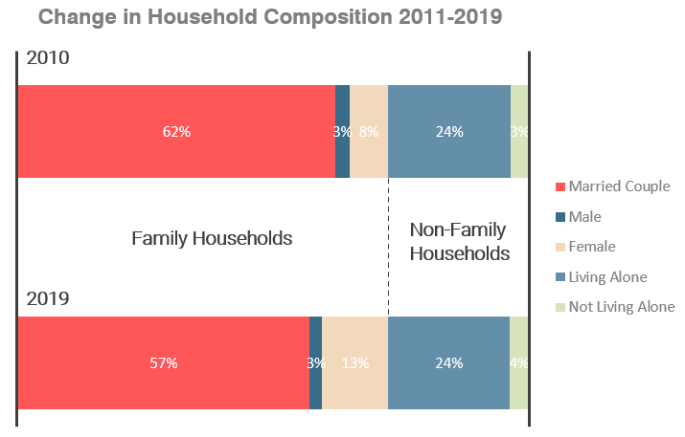

*Source: US Census and American Community Survey*

Between 2011 and 2019, Berlin saw a 3% increase in family households and in non-family households. Family households are households with two or more related individuals living together, while a non-family household represents a single-person or two or more unrelated individuals living together such as roommates or unmarried couples. The growth in family households is largely driven by a 62.5% increase in female family households. Approximately 57% of all households were family households in 2019, which coupled with the age distribution data suggests that the primary driver of family household growth is in older populations, which may not have any children.

Between 2010 and 2019, the number of households in Berlin increased by 270 while population increased by 379. Household composition has remained largely unchanged meaning that these small increases in population and new households have been spread across household types.

Despite the largest percent increases in 3- and 4- person renter households at +85% (+53) and +190% (+57) respectively, the largest growth in absolute terms was in 2-person owner households which grew by 25.7% or 596 households. Based on the shifts in age composition it would suggest that older populations and younger wealthy households could be migrating into Berlin to achieve or maintain homeownership. Additionally, Berlin has experienced net increases of 423 households headed by a resident 60 years or older which is most likely growth in 2-person family households.

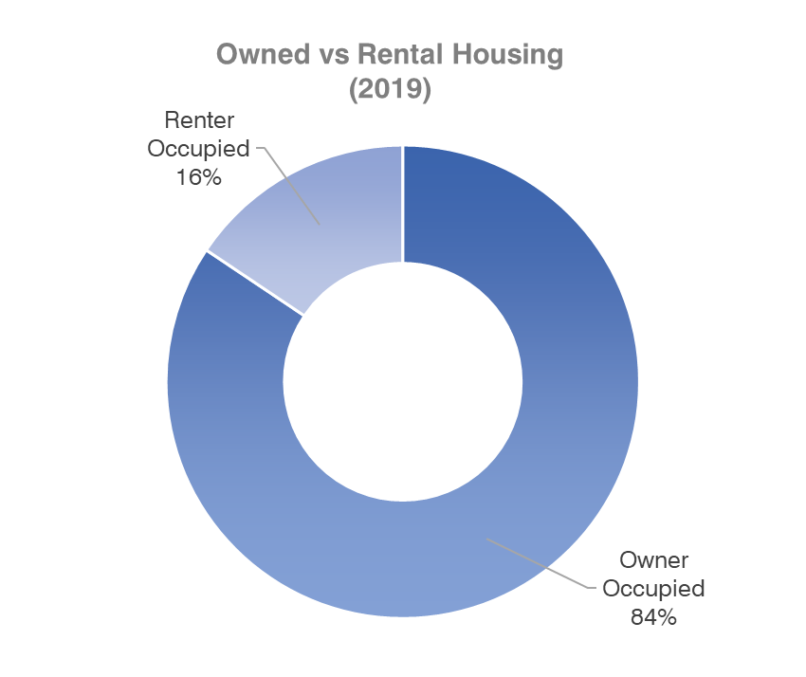

*Source: American Community Survey*

Based upon the 2010 US Census, Berlin had 8,140 housing units. Most (84%) of the Town’s housing stock is owner occupied. 16% of housing is renter occupied (1,300 units). The home ownership rate is twenty percentage points higher in Berlin that it is in Hartford County. The Town has identified 592 units of purpose-built rental housing so over half the Town’s rental housing stock is in other types of housing units, including single family houses and condominiums.

Most (79%) of Berlin’s housing is single-family detached housing. Housing with 20 or more units comprises 5% of the town’s housing. Berlin’s housing supply is oriented more towards single-family housing than Hartford County or the State. Compared to both Hartford County and the State, Berlin has a much higher share of single-family detached housing. Single-family detached housing typically has a higher housing cost (both rental and ownership) than other forms of housing. The town has, however, seen an increase in residential structures with 10 to 19, 20 to 49 and 50+ units suggesting that an emerging segment of Berlin’s housing portfolio are larger multi-family developments. This trend is likely to continue with the recent approvals of multi-family rental housing.

*Source: American Community Survey*

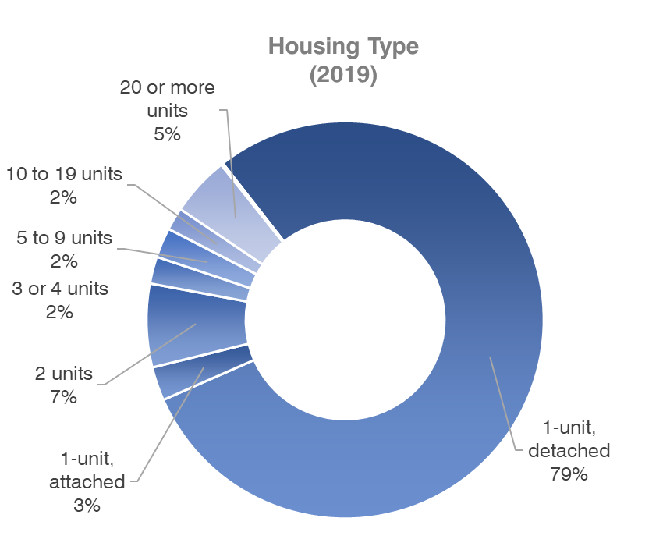

In 2019, 4.7% of Berlin’s housing stock was classified as vacant. This was a lower rate of vacancy than the 2011–15 ACS estimate of 5.1%. Berlin’s vacancy rate, when looking at only owner and renter units actively being marketed, is much lower (1.1% out of the total housing units in 2019). A healthy vacancy rate for a community is typically between 4% and 6%.

*Source: American Community Survey*



**Vacant Housing Units by Category (2011-2019)**



The inventory of vacant units that are for sale or for rent in Berlin is in a relatively unhealthy range. In 2019, there were 81 units listed as vacant for sale and 45 vacant for rent. This is out of a total housing stock of 8,584 units. CT State Population projections estimate that Berlin will add over 200 residents over the next two decades. The projections from the state do not reflect the recently approved, but not yet permitted residential units in Berlin. These units will add to the current housing stock which will help reduce some pressures on housing demand and are clearly responding to the strong market for rental housing we are seeing not only in Berlin, but across the United States.

While housing units have been added since 2010, housing permit activity over the past decade in Berlin has been at its lowest levels over the past 30 years. Permit activity followed similar trends as both Hartford County and the State between 1990 and 2018. Looking at the changes in supply and demand of housing over the past two decades provides insight into the dynamics that affect housing market prices and affordability. Over the past two decades, housing production activity, based on building permits issued for new construction were exceptionally high in the early 2000’s particularly for large multi-unit structures but dropped off significantly following the Great Recession (2007 – 2009). The recently approved larger multi-family housing projects are expected to reverse this trend. Permits for new housing construction have not returned to prerecession levels; however, Berlin has seen steady permitting levels for single unit structures over the latter part of the last decade and a recent increase in multi-family structures in the last three years.

**Net Change in Total Housing Units (2000-2020)**

*Source: CT DECD*

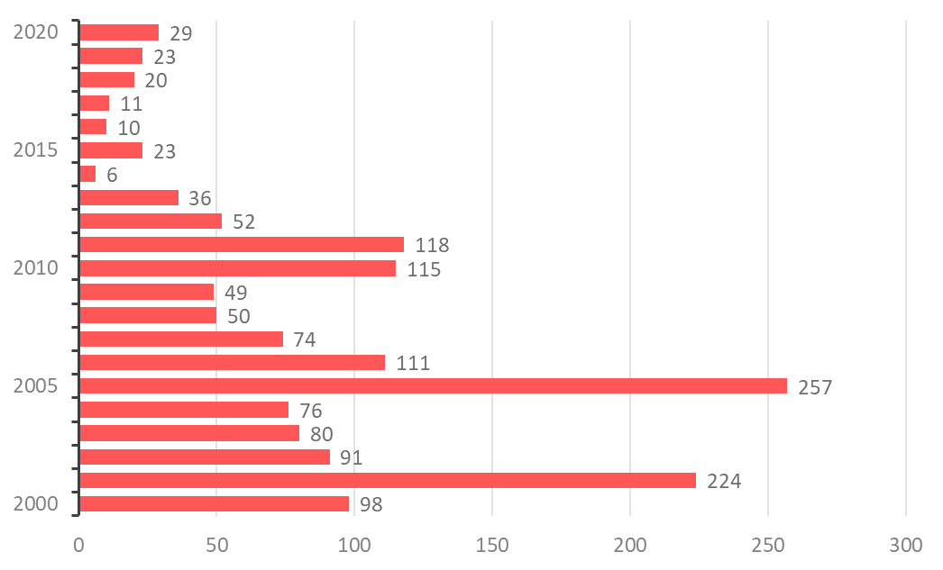

*Source: CT DECD, Town of Berlin*

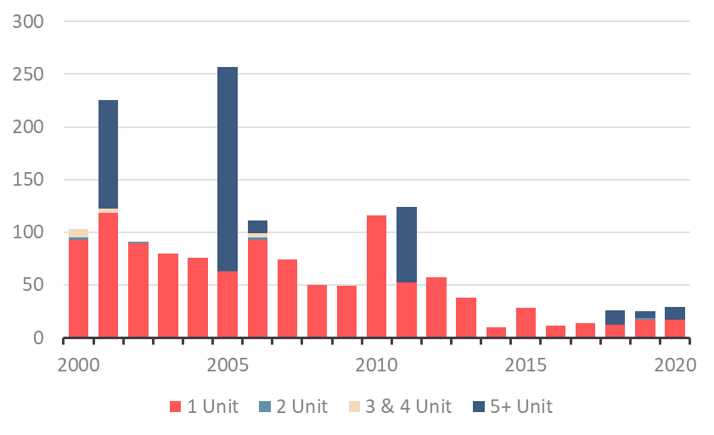

**Housing Permits Issued Annually by Units in Building, Berlin, CT (2000–2020)**

Berlin’s housing ranges in age with nearly half (47%) of housing constructed more than 50 years ago. After decades of double-digit percentage housing growth in the decades following 1950, only 3% of the town’s housing has been constructed since 2010.

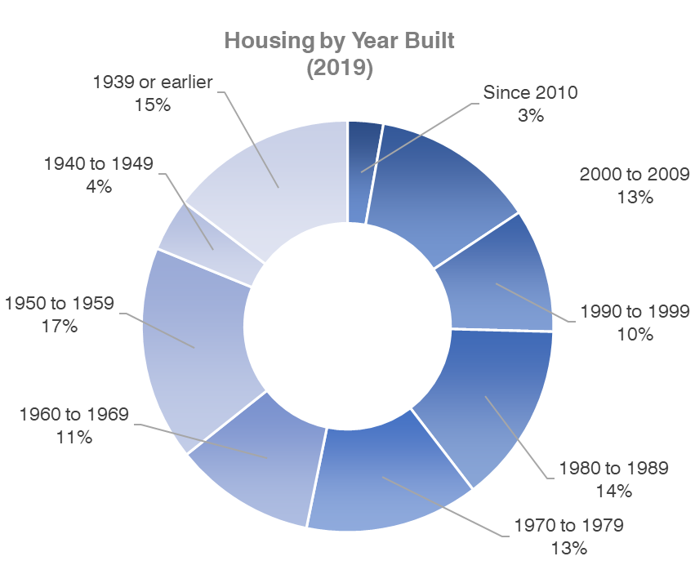

*Source: American Community Survey*

# A2: Economic Indicators

Berlin households have become increasingly wealthier with the fastest growth occurring in households earning more than $200,000 per year. Since 2011, Berlin saw a 38% growth in households earning more than $150,000 per year. This was a faster rate than Hartford County (29%).

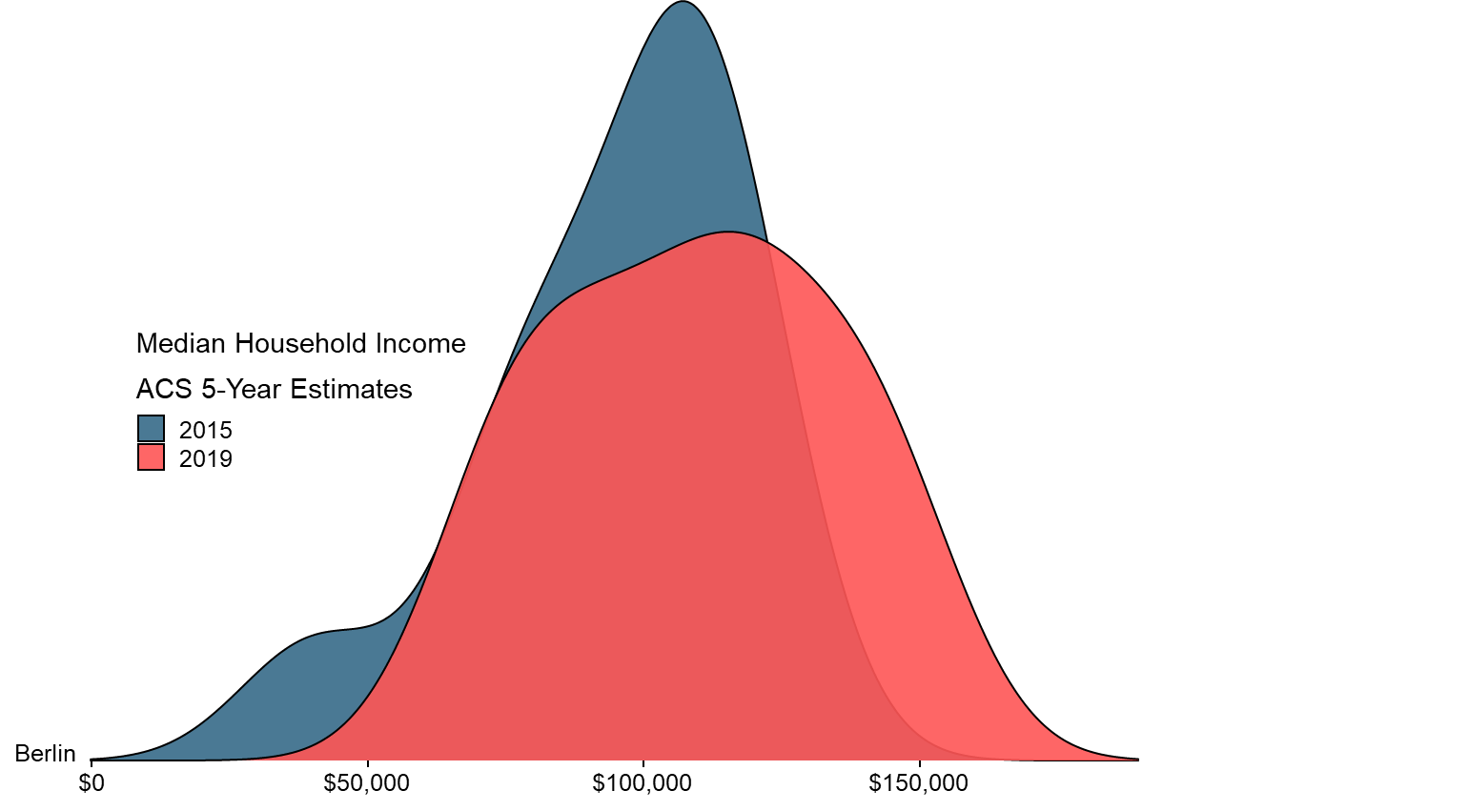

**Median Household Income (2015 vs 2019)**

Across all races and ethnicities, where data was available, median household incomes have increased over the past decade. This suggests an increasing level of wealth in Berlin, which will likely continue the trend of increasing prices for both owner and renter units. For lower income households, housing cost inflation associated with rising incomes could adversely impact their ability to find affordable housing options and remain in town. These trends may also be impacting the ability of lower income households to enter the homeownership market over time as prices continue to rise.

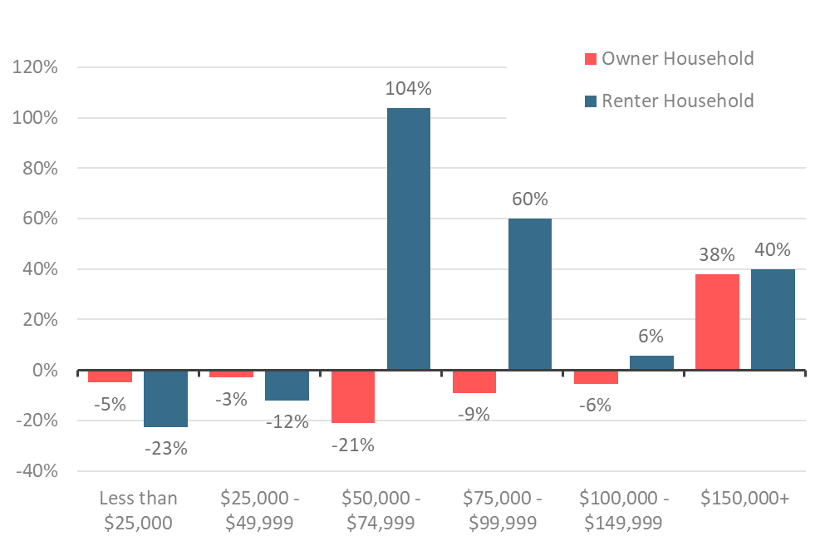

**Change in Household Income by Tenure   
(2011-2019)**

*Source: American Community Survey*

Berlin’s owner households earning $150,000+ have increased by 38% or 618 households. Renters in this same income band increased by only 6 households (40%). For renters in the middle-income bands, $50-$74.9k and $75-$99.9k, the number of households have increased by 104% (159) and 60% (48) respectively. The Town does not currently have a large stock of luxury rental units which creates a situation where higher income renter households reside in units that are priced lower than what they technically could afford. This creates added competition for middle-market rental units which a larger share of the town’s renter population may be vying for.

Renters compose a higher share of lower income households in Berlin, but a much lower percentage when compared to Hartford County. Most renters fall within the three lowest income brackets which are below $75,000 a year. Lower income renter households face numerous challenges ranging from paying rent, containing cost burdening as prices escalate and finding affordable housing options in an increasingly expensive market. Low incomes increasingly impact a household’s ability to enter the homeownership market over time as prices continue to rise.

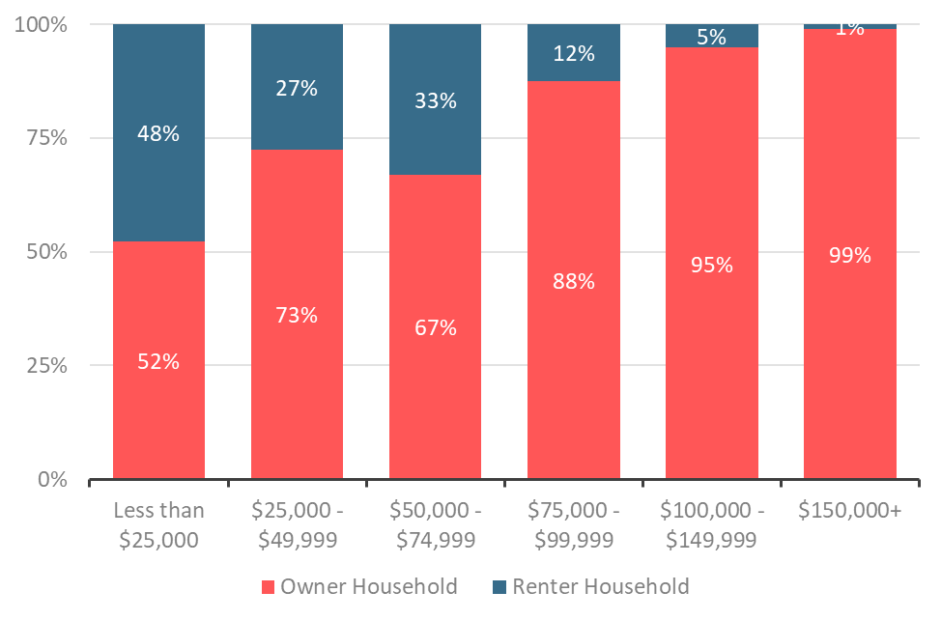

**Share of Households by Tenure & Income (2019)**

*Source: American Community Survey*

Many renter households in Berlin are considered housing cost burdened. HUD considers a household to be cost burdened if it spends more than 30% of its monthly income on housing costs. About 49% of all renter households in Berlin are cost burdened which is slightly below state averages.

*Source: CHAS*

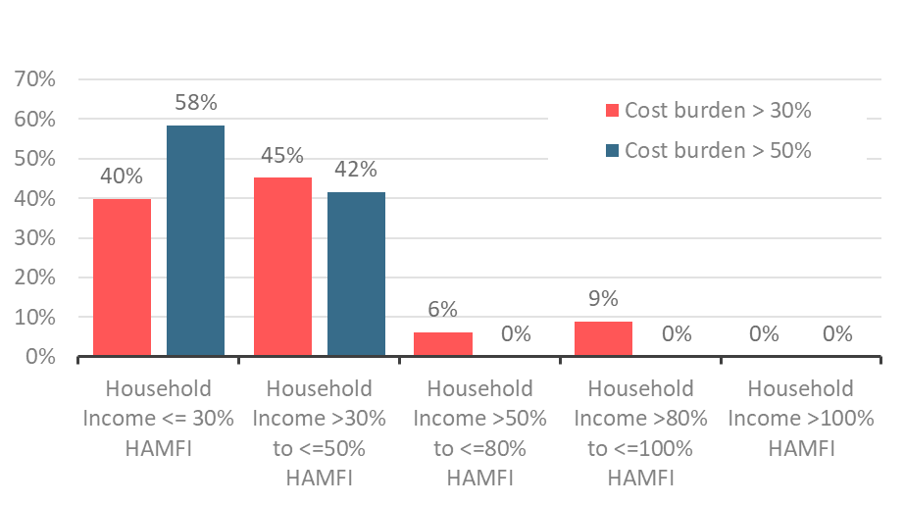

**Renter Income by Cost Burden (2018)**

The challenge for households spending more than 30% of their income on housing costs is it leaves less money for spending on other necessities such as food, transportation, education, healthcare, and childcare. Finding ways to build more housing that is affordable to renters is one way of helping to keep cost burdening down.

Renters in Berlin are more likely to be cost burdened compared to owners. According to data for 2018 from HUD, 47% of renters were spending more than 30% of their income on housing costs compared to only 21% of homeowners in 2018. 27% of those renters were spending more than 50% of their income compared to only 10% of homeowners.

# A3: Housing Market Assessment

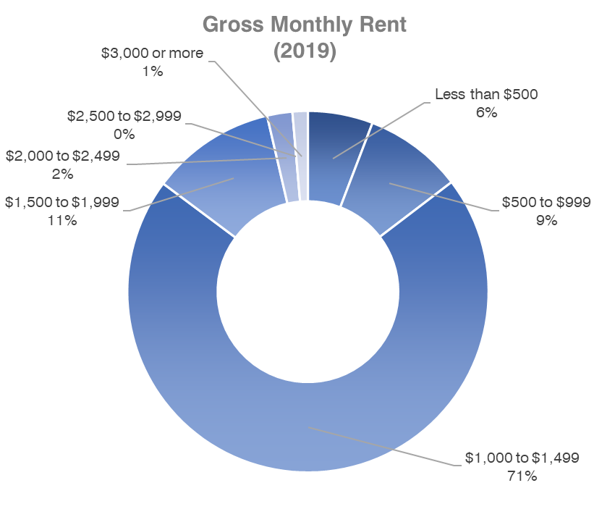

*Source: American Community Survey*

## Rental Market

The Town’s rental housing market is comprised of about 1,300 units, 592 units of which are purpose-built rental housing. Another 494 rental units, including 178 affordable units, are approved but not yet built so the supply of rental housing in Berlin is expected to significantly increase. It is likely that the new rental housing units will expand the rental offerings on both the low and high ends of the price spectrum.

Most (85%) of Berlin’s rental housing costs more than $1,000 per month. Rents at or above $1,000 have increased by 39.1% between 2011 and 2019. In Berlin, the largest share of rental units are those priced between $1,000 and $1,499, comprising 71% of rentals. Only 15% of rental units have a gross rent under $1,000 per month.

Prior to 2015, there were not rental units priced above $2,000 a month according to data from the American Community Survey. By 2019, there were 45 units priced at or above $2,000 a month. At the same time, the number of rental units priced below $1,000 fell by 47.8% (loss of 166 units). There was also a 134% increase (increase of 79 units) in rental units charging $1,500-$1,999 per month. Based on the gross rent distribution, most rents are shifting to higher costs particularly in units charging more than $1,500.

According to Zumper, between 2015 and 2021 average rents for two-bedroom units in Berlin were up 71%. This is a significantly larger increase than for rental units in general as the ACS 5-Year estimates suggest that over the past decade gross rents across all unit types have increased by 10.4%. According to rental information from Zillow, the Hartford Metro Area experienced an increase in observed rents for all units of 16% going from an average of $1,261 a month in 2015 to $1,465 a month in 2021.

*Note: Variation of rental rates presented in this analysis is due to varying data sources referenced. Data is provided for reference purposes only.*

*Source: American Community Survey*

**Change in Gross Rent Distribution   
(2011-2019)**

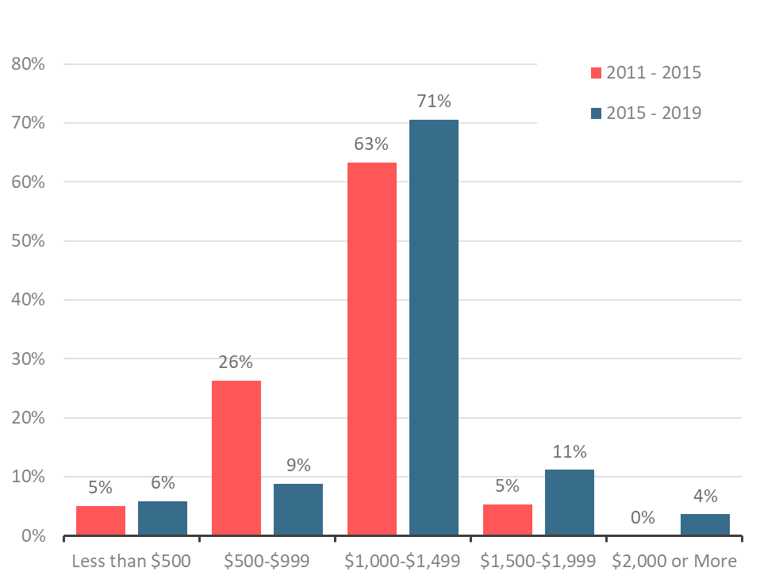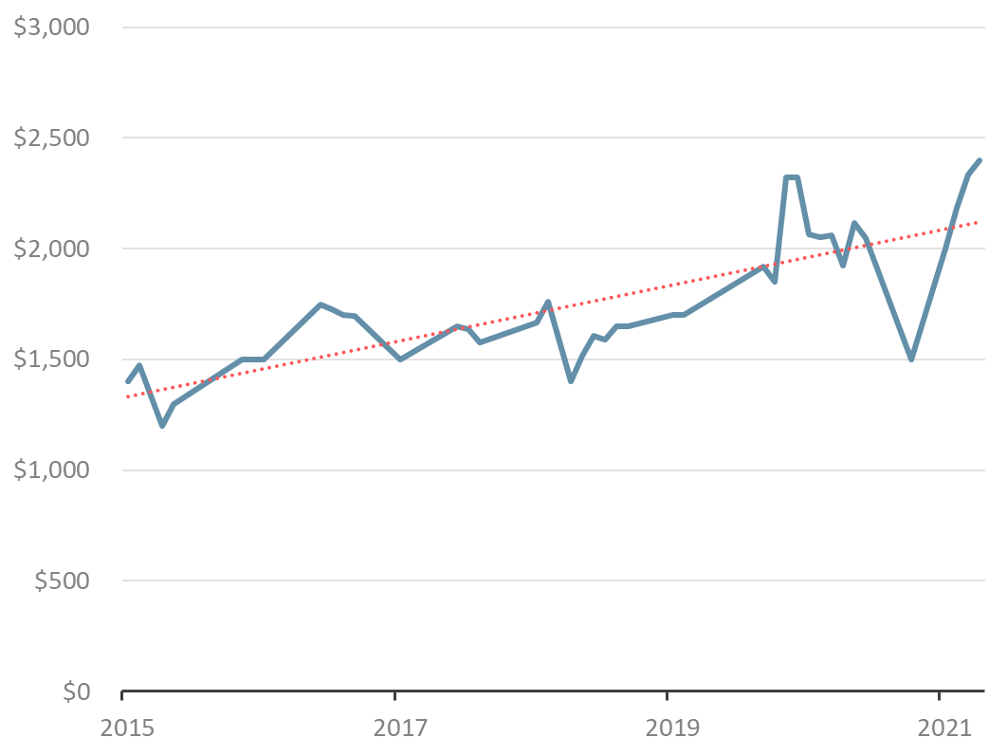

**Average Change in Rent for a 2-Bedroom   
(2015-2021)**

*Source: Zumper 2015-2021*

## Ownership Market

**Zillow Home Value Index** (2000-2020)

*Source: Zillow.com*

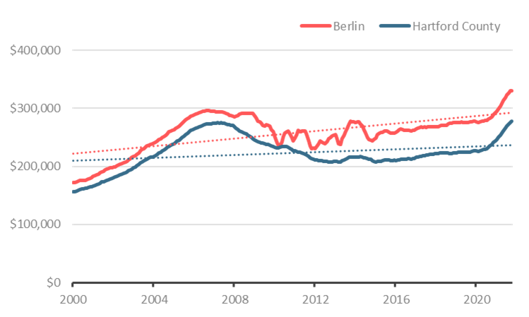

Since 2000, Zillow Housing Research estimates that the median home value in Berlin has experienced a 92% increase. Median sales prices in Berlin are rising. This trend has occurred in many cities and towns in Connecticut, particularly in 2020 and 2021 with existing homeowners selling at top of market prices to higher income households looking for single-family homes in suburban communities.

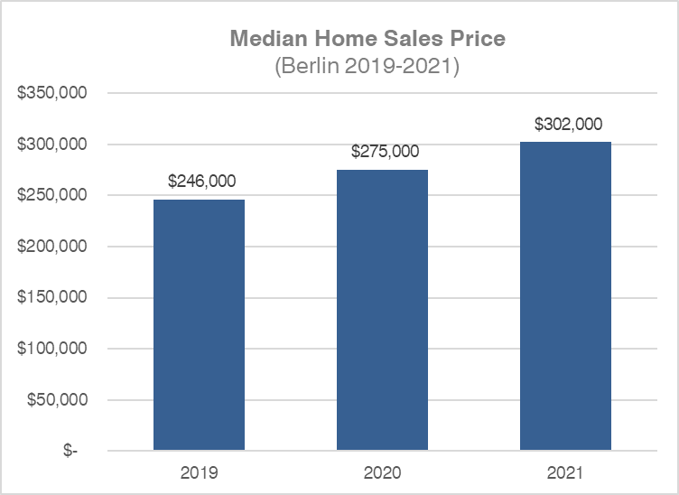

*Source: Redfin*

|  |  |  |
| --- | --- | --- |
| Berlin Condo Sales | | |
| Year | **Units Sold** | **Median Price** |
| 2019 | 81 | $225,000 |
| 2020 | 63 | $207,000 |
| 2021 | 77 | $255,000 |

*Note: Variation of sales prices presented in this analysis is due to varying data sources referenced. Data is provided for reference purposes only.*

|  |  |  |
| --- | --- | --- |
| Berlin Single Family Sales | | |
| Year | **Units Sold** | **Median Price** |
| 2019 | 317 | $251,500 |
| 2020 | 294 | $275,000 |
| 2021 | 326 | $302,100 |

## CHFA Mortgage Market

|  |  |  |
| --- | --- | --- |
| CHFA Mortgage Program | | |
| Sales Price and Income Limits - Berlin, CT 3/23/22 | | |
| Household Size | **Income Limit** | **Sales Price Limit** |
| 1 or 2 persons | $104,300 | $367,580 |
| 3 or more persons | $119,945 | $367,580 |

The Connecticut Housing Finance Authority (CHFA) provides below-market interest rate mortgages and down payment assistance loans to first-time and other select homebuyers within certain income limits for the purchase of affordable housing across Connecticut. The current income limits for households of two persons or less in Berlin is $104,300 and $119,945 for households with three persons or more. The sales price limit of homes in Berlin is $367,580.

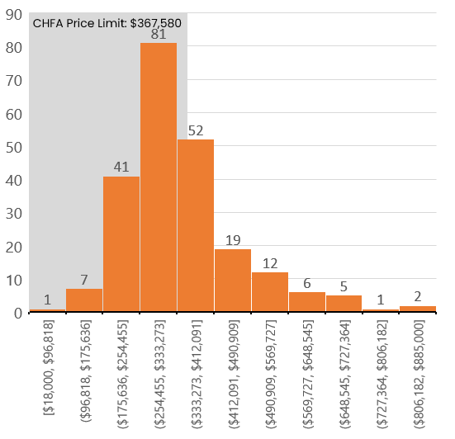

**Distribution of Single-Family Home Sales** (2021)

*Source: Redfin*

In 2021, 159 of 227 home sold in Berlin (70%) were below the CHFA price limit of $367,580. This means that only 30% of Berlin’s housing supply is priced above the limits that would allow the use of a CHFA loan.

By comparison, 96% of condominium sales (53 of 55) in 2021 were within the CHFA price limit. Compared to median single-family home sales prices, median condominium sales prices grew more conservatively (6%) over the five-year period between 2017 and 2021.

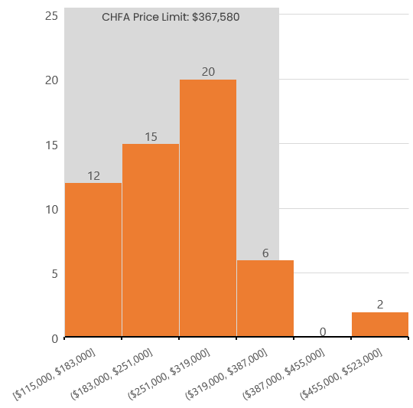

**Distribution of Condo Sales**(2021)

*Source: Redfin*

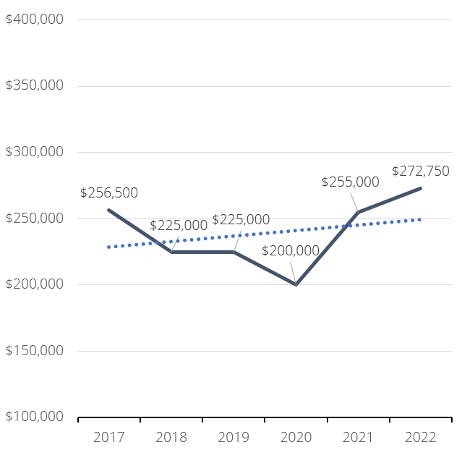

**Median Sales Price of Condos**(2017-2021)

*Source: Redfin*

*Note: Variation of sales prices presented in this analysis is due to varying data sources referenced. Data is provided for reference purposes only.*

# A4: Gap Analysis

Berlin has made significant progress in creating affordable housing but there is a need for more affordable home ownership and rental opportunities. A “gap analysis” is a methodology for estimating the number of additional housing units that would be needed at different price points to provide enough housing supply at each price point to satisfy the demand of existing Berlin residents so that existing residents do not need to pay more than 30% of their income on housing. What follows is a gap analysis for Berlin. The intent of this analysis is to provide a theoretical estimate of the additional housing units needed in each price range for both renters and homeowners. Some of the data sources used in this gap analysis section are different than the data sources used in other sections of the report.

Based on the data collected and analyzed for Berlin, households were divided into three distinct groups covering both renters and owners: upper income buyers and renters, moderate income, and lower income. The upper income group accounts for 56% of all households, while the moderate or middle-income comprise about 24%, with the lower income households accounting for 21% when categorized by household income.

The home purchasing power of the top 47% of households is over $275,000 greater than the maximum value for the bottom 53% of households based on what these households could technically afford to pay for a home. These households could afford purchase prices starting at $615,150 which is a higher price point than what most homes in Berlin sell for. This means there are higher income households purchasing or renting homes at prices below what they can technically afford, should they choose to do so.

There is still a great need for affordable housing in Berlin. About 45.1% of renter households and 16.7% of owner households earn less than 50% of the area median income (AMI), totaling 1,725 households. These households often experience housing instability, may rely on housing assistance, and typically spend more on housing as a percentage of their overall income.

Households in the middle- and lower-income brackets must compete with greater numbers of households looking for rental and for-sale product given the overall lack of supply at the high end possibly suggesting greater supply is needed for low- to moderate-income households. To put this in perspective, the median sales price of a housing unit sold in Berlin was $315,000 while the median gross rent was $1,200 in 2019.

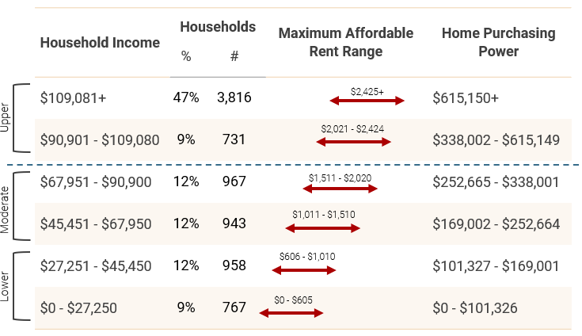

**Renting and Purchasing Capacity of Berlin Households** (2019)

*Source: HUD 2021, ACS, RKG Associates*

Below we have created an affordable housing gap analysis for Berlin that looks at the number of owner and renter households in the community and groups them into six different income cohorts organized by area median income. We then compare the households in each income bracket to the number of units affordably priced to them. By subtracting the number of households from the total number of units priced to each income cohort a gap or surplus is derived for each income cohort. If the number in the graph is negative, that means there are more households at that income cohort than there are affordably priced units. If the number is positive, it means there are more units than households at that income cohort.

For the owner affordability gap, maximum purchase prices for each income category are calculated using both FHA and Conventional mortgage options. This is done because the FHA has a lower down payment requirement which reduces the amount of debt a borrower can take on. The conventional mortgage option assumes a minimum 20 percent down payment.

In the case of Berlin, there are more potential buyers in the higher income brackets than there are housing units that match their maximum affordable housing prices. For households earning at or below 50% of AMI, there is a shortage of 740 housing units in the conventional lending scenario, and a shortage of 900 units in the FHA lending scenario. The maximum affordable home price for households earning below 50% of AMI is $139,577 in the FHA scenario, and $169,001 in the conventional lending scenario. Only about 7% of the homes were valued below $175,000 in 2019, but 16.7% of the owner households earn at or below 50% of AMI.

Units affordable to households with incomes between 50-100% of AMI account for 42% of Berlin’s owner units in the FHA lending scenario and 61% in the conventional lending scenario, yet only 21% of owner households have incomes that fall within this grouping. There is a net surplus of 1,464 units in the FHA scenario, and 2,816 units in the conventional lending scenario, indicating higher income households are likely buying down in Berlin’s market since overall vacancy for homeowner units is relatively healthy.

Households in Berlin earning more than 100% of AMI account for 63% of households. The supply of units priced to meet that demand account for 55% of all owner units in the Federal Housing Authority (FHA) scenario and 33% in the conventional lending scenario. There is a deficit of 564 units in the FHA scenario and a deficit of 2,077 units in the conventional lending scenario for households above 100% AMI. This indicates a potential market for new higher priced housing that could ease the competition for high-to-moderate income units. Label the units on the x and y axis

**Supply and Demand Gap for Ownership Housing Units**(2019)

*Source: HUD, ACS*

Homes financed by the Connecticut Housing Finance Authority (CHFA) are considered as affordable units under Connecticut’s 8-30g affordable housing statute. Therefore, another way to consider the affordability of Berlin homes and condos is to analyze Berlin house and condo sales price data in relation to the maximum price limits for CHFA financing in Berlin. As noted above, both the median home price and condo price in Berlin are below the maximum CHFA home price limit. Therefore, by this measure Berlin has a significant supply of homes that are affordable.

The rental supply is tight at both the lowest end and high end of the income spectrum. For extremely low-income renter households, the supply of affordable and available units is especially limited. There are 252 more households earning less than 30% of AMI than available affordably priced units with monthly gross rents at or below $605. Only 6.1% of occupied rental units have monthly rents below $605, while 25.6% of renter households earn at or below 30% of AMI. Units priced to households at or below 30% of AMI are typically provided by government organizations like housing authorities and non-profit affordable housing developers. These can also be provided using financial subsidies like housing vouchers.

Units priced between 50-100% of AMI account for 80% of all rental units, while only 40% of renter households have incomes corresponding to this price bracket. Hence, there are 505 units that are likely rented by households with lower incomes who are likely spending more than they should on housing costs.



**Rental Supply and Demand Gap**(2019)

*Source: HUD, ACS*

Households earning more than 100% of AMI account for 16.9% of all renter households, but the supply of units at this price point accounts for only 3.6% of the rental stock. The gap between potential demand and actual supply for households above 100% AMI is 171 units. Some of this gap may be mitigated if and when the new approved multi-family rental developments are permitted, constructed, and occupied.

The lack of higher priced rental units in Berlin puts pressure on the supply of housing priced for lower income households. Higher income households have more choices in the housing market and are likely renting units at a lower price point than they can afford.

# A5: Zoning Summary

***Summary Table of Housing Options within Zoning Regulations***

|  |  |  |  |  |  |  |  |
| --- | --- | --- | --- | --- | --- | --- | --- |
| Zoning District | Low Density Multifamily (4 units per acre or less) | High Density Multifamily  (More than 4 units per acre) | Affordable Housing Incentive | Affordable Single-Family Housing Development | Adult Housing | BHA Elderly Housing | Accessory Dwelling Unit |
| R-7 | x |  |  |  |  |  |  |
| R-11 |  |  |  |  |  |  |  |
| R-15 |  |  |  |  |  | x | x |
| R-21 |  |  |  | x |  | x | x |
| R-43 |  |  |  | x |  | x | x |
| R-86 |  |  |  | x |  | x | x |
| PR-1 | x |  |  |  | x |  |  |
| PR-2 | x |  |  |  |  |  |  |
| PR-3 | x | x |  |  |  |  |  |
| POR | x | x |  |  |  |  |  |
| MR-1 |  |  |  |  |  |  | x |
| MR-2 | x |  |  |  |  |  |  |
| KO | x | x |  |  |  |  |  |
| PDD |  |  |  |  |  |  |  |
| CCD-1 | x |  |  |  |  |  |  |
| CCD-2 | x | x |  |  |  |  |  |
| BTD | x | x | x |  |  |  |  |
| OT-2 |  |  |  |  | x |  |  |
| PI-2 |  |  |  |  | x |  |  |
| WHD | x | x |  |  |  |  |  |

Berlin has nine residential zoning districts. These zoning districts allow for a range of residential development with single family housing being the most common type of housing permitted. Residential (R) districts are named by minimum lot size. By example, an R-7 district requires a minimum lot size of 7,000 square feet or 0.16 acres.

***Four districts are single-family residential (R-86, R-43, R-21, R-15)***

The single-family residential districts are intended to provide suitable areas for residential development appropriate to the environmental characteristics of the land and the character of the neighborhood. The districts are also intended to accommodate certain nonresidential uses which are compatible with residential uses while preserving neighborhood character and property values.

* These districts permit single-family detached dwellings and group homes
* Open space subdivisions and design open space developments are permitted by special permit in the R-21, R-43, and R-86 districts
* Neighborhood affordable housing projects are permitted by special permit in the R-21, R-43, and R-86 districts

***Two districts are single and two-family residential (R-11, R-7)***

The purpose of R-11 and R-7 single-family and two-family residential districts is to provide suitable areas for moderate density residential development appropriate to the character of the neighborhood, where adequate facilities and services are present. The R-11, R-7 districts are also intended to accommodate certain nonresidential uses which are compatible with residential uses while preserving neighborhood character and property values.

* Single-family residential uses allowed in both R-11 and R-7 districts
* Two-family residential uses allowed only in the R-7 district

***Three districts are planned residential (PR-1, PR-2, PR-3)***

The purpose of planned residential districts PR-1, PR-2, and PR-3 is to provide appropriate locations for a range of residential densities where adequate facilities and services are present.

* Residential uses permitted by right in these districts include single-family detached dwellings
* Multifamily developments are permitted by special permit
* The minimum lot area is 20 acres for the PR-1, 7 acres for the PR-2, and 5 acres for the PR-3

**Special Use Zones with a Residential Component**

***Planned Office Residential (POR)***

The purpose of the POR district is to provide for the development of multifamily residential uses, offices and related uses in a manner which is well-designed and compatible with nearby single-family residential uses.

* Permitted by right residential uses include single-family detached dwellings
* Permitted by special permit: group homes or community care facilities, multifamily developments

***Mountain Reserve Districts (MR-1 and MR-2)***

The purpose of the mountain reserve districts is to permit low intensity development which is appropriate for the environmentally sensitive hilly areas of Berlin to preserve their environmental and aesthetic qualities.

* Permitted by right residential uses include single-family detached dwellings and group homes
* Multi-family dwelling developments are permitted in the MR-2 district by special permit

***Kensington Overlay Zone (KO)***

Purpose: This section of the Regulations is intended to allow the Commission to modify some of the use and dimensional standards in the underlying zoning districts in the Kensington area in order to:

1. Promote the development of a transit-oriented, pedestrian-friendly, village-type environment in the Kensington Village area and within walking distance to the Berlin train station.
2. Help create an attractive and inviting, pedestrian friendly environment.
3. Allow and encourage mixed use development that offers a high intensity of uses.
4. Help provide for a variety of housing opportunities in Berlin.
5. Help preserve, restore, and enhance the overall village character and feeling.
6. Ensure high quality site planning, architecture, and landscape design that will complement and enhance the area and surrounding neighborhoods.

The KO is divided into three areas: Village Core Area 1, Village Core Area 2, and Village Redevelopment Area.

Village Core Area 1 regulations:

* 70% of the total number of dwelling units shall not have more than one bedroom.
* Maximum of 26 dwelling units per acres
* One acre minimum

Village Core Area 2 regulations:

* No dwelling unit shall have more than one bedroom
* Maximum of 6 dwelling units per acre
* One acre minimum

Village Redevelopment Area regulations:

* No more than 20% of dwelling units shall have more than two-bedrooms including dens, office or similar undesignated room (provided not used as a bedroom); and
* Maximum of six dwelling units per acre
* Multi-family developments will require a minimum lot area of 1.0 acre

*Affordability Guidelines of Kensington Overlay Zone*

* Any application proposing affordable housing units shall be deed restricted to comply with all aspects of the Connecticut General Statutes §8-30g.
* Any application proposing affordable units shall submit an affordability plan specifying the procedures for establishing and monitoring the affordability restrictions and identifying the Administering Agency which will monitor and enforce the affordable housing restrictions.
* Affordable units shall be of comparable size, quality, and level of finish as the overall development and shall be completed and occupied on a proportional basis.
* Prior to the issuance of a building permit, the developer shall submit documents to the Administering Agency such that the Administering Agency can certify compliance with applicable statutory and other requirements.

***Planned Development District***

The purpose of this district is to:

1. Enable the development of specific areas in accordance with an overall master plan for such area;
2. Encourage a mixture of compatible uses and structures to create a sustainable and attractive environment;
3. Be flexible in order to allow for innovative design techniques, accommodate unique uses and encourage creative approaches to development issues; and
4. Result in a development that demonstrates a high regard for design and that is compatible with the historic, cultural and geographic qualities of Berlin.

***Workforce Housing Development***

A Workforce Housing Development (WHD) is a multi-family housing development that qualifies as an “assisted housing” development as defined in Connecticut General Statutes §8-30g (a)(3).

This purpose of the WHD is to provide standards for development or redevelopment, on a cooperative basis between the Town and an identified development entity with experience in mixed-income, multifamily workforce housing, on parcels identified by the Town as appropriate for such housing; and to provide dimensional and design standards that will ensure a high-quality residential environment that is compatible with adjacent and neighboring commercial and residential uses.

**Commercial Use Districts with a Residential Component**

***Commercial Core Districts***

The purpose of the commercial core design districts is to encourage the orderly development of a shopping area for the town which provides the opportunity for creative and flexible architectural design, the sound interrelationship of buildings to open spaces, pedestrian and vehicular circulation, landscaping, parking areas and business uses and to carry out the recommendations and proposals for circulation and use contained in the duly adopted plans and policies of the commission.

The Commercial Core Districts (CCD-1 and CCD-2) allow the following:

* Multifamily dwelling units, at a maximum density of four units per acre, if not located at street level or on the first floor of a building.
* Multifamily dwelling units at a maximum density of 2.5 units per acre for persons 55 years of age or older.
* CCD-2 District: For parcels of a minimum size of four acres or larger, multifamily residential uses at a density of up to ten dwelling units per acre, with a maximum height of four stories or 50 feet, whichever is less, shall be permitted in the CCD-2 district, subject to site plan and special permit approvals by the commission in accordance with Sections XII and XIII, provided that the first floor area of the building along the frontage on a public street, and other areas in which high volumes of pedestrian traffic are anticipated consist entirely of stores and shops for the conduct of retail business or personal service business.

***Berlin Turnpike Development Zone (BTD)***

The purpose of this zone is to allow the Commission to modify some of the use and dimensional standards in the underlying zoning districts of the BT-1, BT-2 or PS-B zones along the Berlin Turnpike, in order to:

1. Promote the development of a mixed-use development including housing opportunities in close proximity to the Berlin Turnpike’s commercial uses to encourage and inspire commercial development along the road frontage of the Berlin Turnpike.
2. Provide for a variety and diversity of housing opportunities in Berlin to meet residential demands in the Town of Berlin by providing opportunities for current Berlin residents to age in place and provide housing opportunities in Berlin for its growing industrial and commercial sector labor forces.
3. Provide affordable housing opportunities that will contribute to Berlin’s affordable housing stock with size and quality of housing that is comparable to market rate housing opportunities.
4. Encourage the commercial development along the Berlin Turnpike by allowing and encouraging the consumers and the local labor forces to live within walking distance or in close proximity the commercial uses along the Berlin Turnpike.
5. Ensure high-quality site planning, architecture, and landscape design that will complement and enhance the area surrounding the Berlin Turnpike.
6. Offer open spaces and other public amenities for the direct benefit of both the uses in the development and the Berlin community at large.

Permitted Residential Uses: Mixed use development consisting of commercial and residential uses as a special permit use.

* Residential uses shall be setback a minimum 240 ft from the Berlin Turnpike right-of-way.
* Density:
  + There shall be a maximum of four (4) dwelling units per acre, or
  + There shall be a maximum of eight (8) dwelling units per acre provided that twenty percent (20%) of the units are deed restricted as affordable housing
  + A Master Plan is limited to a maximum of 200 residential units total.

**Industrial Use Districts with a Residential Component**

Berlin has one industrial district that permits housing development. The Office Technology 2 (OT-2) District permits adult housing by special permit.

**Additional Regulations**

***Adult Housing***

Adult housing is permitted in the PR-1 zone, PI-2 zone, the OT-2 zone, and all other zones where multifamily housing is permitted, subject to special permit and site plan approvals.

Adult Housing is defined in the regulations as:

1. Adult dwelling unit. A dwelling unit which fully complies with the provisions of the United States Fair Housing Act as amended, as it pertains to “housing for older persons.” This includes compliance with any and all rules and regulations promulgated by the United States Department of Housing and Urban Development which govern the implementation of such act.
2. Adult housing development. A housing development wherein all dwelling units are restricted to adult dwelling units as defined above that comply with Section AA.2 hereof.

Purpose and standards:

The purpose of this section is to provide adult housing options for persons 55 years of age and older. It must be demonstrated that there is a reasonable need within the Town of Berlin for the housing proposed.

Each adult dwelling unit shall be occupied by:

* At least one person who is 55 years of age or older.
* A spouse, companion or relative of an occupant who qualifies pursuant to Section AA.2.a.i. above.
* Occupant who qualifies pursuant to Section AA.2.a.ii. of the regulations who survives his or her spouse, companion or relative.
* Occupant who qualifies pursuant to Section AA.2.a.ii. of the regulations whose spouse, companion or relative has entered into a long term continuing care facility.
* An employee of an occupant who qualifies pursuant to Sections AA.2.a.i., ii. or iii. of the regulations, who performs substantial duties related to the care of the occupant who qualifies under Section AA.2.a.i., ii. or iii. of the regulations.
* In no event shall any dwelling unit within the development be occupied by a person under the age of 18 years.

***Housing for Elderly Persons***

The purpose of this allowable use is to promote the public health, safety and general welfare of the community by providing decent, safe and sanitary housing units for elderly persons (as defined in the Connecticut General Statutes§ 8-113a(m)) at reasonable rents, to ensure housing facilities specially adapted for elderly persons as a public use in the public interest, and to allow housing for elderly persons within the town in accordance with the appropriate standards, conditions and safeguards as hereinafter set forth in this section. In order to afford the opportunity to the Berlin Housing Authority to provide “Housing for Elderly Persons” under Connecticut General Statutes § 8-112a et seq. (chapter 128, part VI), housing for the elderly where permitted as a municipal use shall be subject to site plan and a special permit approvals by the Commission in accordance with the requirements of Sections XII and XIII of the regulations and subject to specific standards, conditions and safeguards.

The construction of residential dwelling units for the elderly under this section is permitted for detached dwellings, semidetached dwellings and attached dwellings such as apartments, garden apartments and townhouses, but not for hotels, motels, rooming houses, boarding houses and lodging houses or tourist homes. No elderly housing unit shall have more than two bedrooms and not more than 50 percent of elderly housing units shall be two-bedroom units.

***Accessory Dwelling Unit Regulations***

* Limited to single-family residential units more than five years in age.
* Limited to MR-1, R-86, R-43, R-21, and R-15 zones by special permit
* Limited to owner occupied residences
* ADU occupancy limited to two persons aged 55 years or older
* Age restriction is waived if unit is deed restricted to a rental cost of 30% of 80% of the area median income for a two-person family.
* ADU limited to principal dwelling or attached garage – not allowed in accessory structure
* Floor area to be no less than 400 square feet and no more than 700 square feet.
* Annual certification of owner occupancy is required. Failure to certify occupancy will result in forfeiture of the special permit.

***Neighborhood Affordable Housing Development***

The purpose of the NAHD is to permit and regulate the development of affordable, detached single-family dwellings within well-planned, mixed income neighborhoods. This section is adopted pursuant to Connecticut General Statutes § 8-2, as amended by Public Act 91-392.

* NAHDs are permitted, subject to special permit and site plan approvals by the Commission, in the R-86, R-43 and R-21 districts.
* NAHDs are limited to 50 dwelling units.
* No more than 100 NAHD units may be approved in any 12-month period.
* NAHDs are required to be at least one mile apart

# A6: Berlin’s Multifamily Housing Inventory

|  |  |  |  |  |  |  |  |
| --- | --- | --- | --- | --- | --- | --- | --- |
| **Project Name** | **Address** | **Affordable Units** | **Market Rate Units** | **Total Number of Units** | **Status** | **Length of Deed Restriction** | **Date Range** |
| **Affordable apartments, not age restricted** | | | | | |  |  |
| Fieldstone Crossing | Deming Road | 72 |  | 72 | complete | 100 years | 2012-2112 |
| River's Edge | Bacon Lane | 16 |  | 16 | complete | 100 years | 2012-2112 |
| **Subtotal** |  | **88** |  | **88** |  |  |  |
| **Mixed income apartments, not age restricted** | | | | | |  |  |
| Newport Center | 848 Farmington Avenue | 4 | 12 | 16 | complete | 40 years | 2014-2054 |
| Deming Ridge* | Deming Road | 27 | 61 | 88 | approved |  |  |
| 404 Berlin Turnpike | 404 Berlin Turnpike | 40 | 160 | 200 | approved |  |  |
| 550 Berlin Turnpike | 550 Berlin Turnpike | 32 | 74 | 106 | application pending |  |  |
| **Subtotal** |  | **103** | **307** | **410** |  |  |  |
| **Mixed income apartments, age restricted** | | | | | |  |  |
| Orchard Ridge* | Webster Street | 96 | 24 | 120 | complete | 70 years | 2002-2072 |
| Sage Pond Place* | Berlin Turnpike | 77 | 7 | 84 | complete | 99 years | 2007-2106 |
| Stonebridge I* | Stonebridge Way | 88 | 22 | 110 | complete | 60 years | 2007-2067 |
| Stonebridge II* | Stonebridge Way | 67 | 17 | 84 | complete |
| **Subtotal** |  | **251** | **63** | **314** |  |  |  |
| **Affordable apartments, age restricted** | | | | | |  |  |
| Marjorie Moore | Kensington Road | 40 |  | 40 | complete |  |  |
| Percival Heights | Colonial Drive | 30 |  | 30 | complete |  |  |
| Berlin Housing Authority | Percival Avenue | 50 |  | 50 | approved |  |  |
| **Subtotal** |  | **197** | **7** | **204** |  |  |  |
| **Total Units** |  | **639** | **377** | **1,016** |  |  |  |

*\*Additional “market rate” units in this development are considered affordable pursuant to C.G.S. 8-30g because the project was financed by the Connecticut Housing Finance Authority.*

**Multi-Family Inventory by Status**

|  |  |  |  |  |  |
| --- | --- | --- | --- | --- | --- |
| **Project** | **# Age Restricted** | **# Affordable** | **# Market Rate** | **Estimated C.G.S. 8-30g Affordable** | **Total** |
| **Projects in Application Stage** | | | | | |
| 319 Main Street, East Berlin |  | 4 | 18 | 4 | 22 |
| 550 Berlin Turnpike |  | 32 | 74 | 32 | 106 |
| Little House Living |  | 6 | 14 | 6 | 20 |
| **Total pending approval** | **0** | **42** | **106** | **42** | **148** |
| **Approved Projects, Not Built** | | | | | |
| Deming Ridge |  | 27 | 61 | 88 | 88 |
| 196 & 224 Berlin Turnpike |  |  | 72 | 0 | 72 |
| Berlin Housing Authority | 50 | 50 |  | 50 | 50 |
| 873 Farmington Avenue |  |  | 8 | 0 | 8 |
| Steele Center |  |  | 76 | 0 | 76 |
| 404 Berlin Turnpike |  | 40 | 160 | 40 | 200 |
| **Total approved not built** | **50** | **117** | **377** | **178** | **494** |
| **Completed Projects** | | | | | |
| Finishers Court |  |  | 20 | 0 | 20 |
| Newport Center |  | 4 | 12 | 4 | 16 |
| Fieldstone Crossing |  | 72 |  | 72 | 72 |
| River's Edge |  | 16 |  | 16 | 16 |
| Orchard Ridge | 96 | 96 | 24 | 120 | 120 |
| Stonebridge I | 110 | 88 | 22 | 110 | 110 |
| Stonebridge II | 84 | 67 | 17 | 84 | 84 |
| Marjorie Moore | 40 | 40 |  | 40 | 40 |
| Sage Pond Place | 84 | 77 | 7 | 84 | 84 |
| Percival Heights | 30 | 30 |  | 30 | 30 |
| **Total Completed** | **444** | **490** | **102** | **560** | **592** |

# A7: Survey Findings

A total of 766 individuals participated in the survey. The general sentiment was slightly in favor of a greater diversity of housing supply with concerns about the potential impact of building more housing in Berlin. Single family homes whether attached or detached were overwhelmingly favored by participants over all other types. Participants also favor ownership homes over rental homes. Almost 800 comments were received in response to open-ended questions and where “other” was provided as an option to a question. While responses varied considerably, one of the primary themes was a concern about the impact of more housing development on schools, Town services, infrastructure, and traffic.

What participants told us about themselves:

* Most are in the 40 to 49 age group (30%), followed by the 50 to 59 age group (23%).
* 74% are White, combined minority group participation was 7%, 19% preferred not to answer.
* Most (24%) spend 30% to 39% of household income on housing. 42% spend more than 30% of their household income on housing costs (this is considered housing cost burdened).
* 52% of participants have households with incomes above $100,000 per year. 20% preferred not to answer.
* Most live in the “Berlin” section of Berlin (44%) or in Kensington (42%).
* 49% have lived in Berlin for 20 or more years, the balance of participants have lived in Berlin for varying ranges of time.
* 94% own their homes.
* 90% live in single-family detached homes.
* 89% have lived outside of Berlin at some point in their lives.
* Most (35%) live in a four-person household. One-person households were least common (8%).
* 77% live in a family household.

What participants told us about housing in Berlin:

* Single-family detached and single-family attached homes were identified as the preferred housing types by most.
* Most (41%) expect their next home to be smaller than their current home. 24% expect their next home to be larger.
* Most (81%) expect to own their next home. Only 5% expect to rent their next home.
* Single-family detached and single-family attached homes were identified as the housing types most expect for their next home. One- or two-story multi-family homes was the next most common response for expected next home type (17%).
* Most expect to move into their next home more than ten years from now (33%). Only 20% expect to move within five years.
* 36% believe that their next home will be in Berlin. Most (46%) are unsure.
* 31% know someone who is likely to be looking for a home in Berlin in the next five years that would benefit from access to more affordable housing.
* Single-family ownership homes (50%) were identified as the type of housing that would be most preferred by the person anticipated to be in the market for a home in Berlin within the next five years. Single-family rental homes were identified next as the likely preferred home (32%).
* 42% believe that there is enough housing in Berlin to meet the Town’s future needs. 32% do not believe there is enough.
* 55% are concerned about the cost of housing or homeownership in Berlin. 39% are not concerned.
* Participants were evenly split (335 yes and 335 no) regarding whether Berlin might benefit from offering more housing choices/options including those that are affordable.
* Most think that the offering of more housing choices and options will have a positive impact on the customer pool for businesses, employee pool for businesses, new families in town, tax base, diversity, and local civic organizations.
* Most think that the offering of more housing choices and options will have a negative impact on Town services, traffic, education, and real estate values.
* Most think that Berlin needs the following ownership and/or rental housing units: affordable ownership units, affordable age restricted rental units for seniors, affordable age restricted ownership units for seniors, non-income restricted/market rate age restricted rental units for seniors, non-income restricted/market rate age restricted ownership units for seniors, and assisted units for seniors.
* Most think that Berlin does not need the following ownership and/or rental housing units: Non-income restricted/market rate rental units.
* Participants were evenly split (231 yes and 231 no) regarding whether Berlin needs non-income restricted/market rate ownership units.
* Most (40%) believe that more rental housing units would have a negative impact.
* Approximately the same share believe that more ownership housing units would have a positive impact (36%) on the community or are unsure about the impact (37%).
* Single-family detached homes, single-family attached (townhouses), and congregate housing/assisted living were the only housing types that most agreed that Berlin needs more of.
* The least identified housing types that participants believe that Berlin needs more of are mobile homes, 3 or more story multi-family, and 3-4 family buildings.
* Most (43% vs 34%) agree with the statement “Providing for affordable housing should be the government’s (Town, State, Federal) responsibility”.
* Most (56% vs 31%) agree with the statement “The Town should look at whether there are any Town-owned properties which could be used for providing housing options”.
* Most (45% vs 36%) disagree with the statement “Private development should be required to provide affordable housing as part of any new housing development”.
* Most (50% vs 32%) disagree with the statement “Private development should be offered incentives (for example, the ability to have more housing units or greater building height) to provide affordable housing”.
* Slightly more (44% vs 41%) agree with the statement ” The Town should look at ways to increase the number of affordable housing units through Town purchases, construction, or rehabilitation of properties”.

*Note: Percentages are based upon total number of responses received per question. Not all survey participants responded to every question of the survey.*