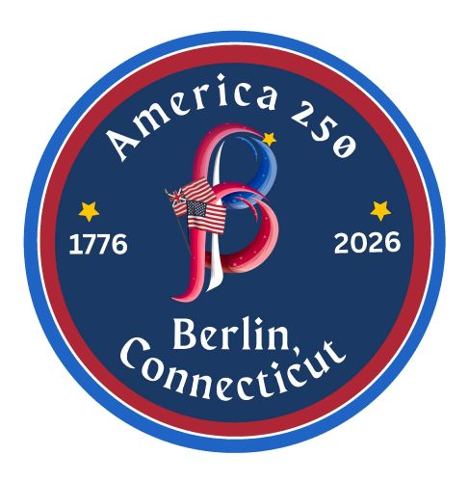
America 250 | Berlin
Steering Committee

Carrie Tyszka, Co-Chair and Library Director 860.828.7120 ctyszka@berlinpeck.org
Kate Wall, Co-Chair and Town Clerk 860.828.7036
kwall@berlinct.gov

Antoinette (Toni) Andreoli toniand17@gmail.com
Chris Barlow chris.barlow@rocketmail.com
Sally Caliandri scaliandri@comcast.net
Sandra Coppola scoppola@berlinct.gov
Mary Kathryn LaRose mklarose@aol.com
Mary Ann Massirio massirio@sbcglobal.net
Elaine Pavasaris elaine@homesweethomect.com
Peter Rosso prosso@berlinct.gov
Ryan Curley rcurley@berlinct.gov

Associate Members:
Peggy Lajoie, President - Kensington Garden Club mlaj123@sbcglobal.net
Chris Cote, Director – Theatre Guild of Berlin, Inc. cmcote187@aol.com
Wendy Kontogouris - Berlin Free Library Association berlinfreelibrary@gmail.com
Dr. Tami Christopher, Executive Director – New Britain Youth Museum/Hungerford Nature Center TamiChristopher@nbymhnc.org

