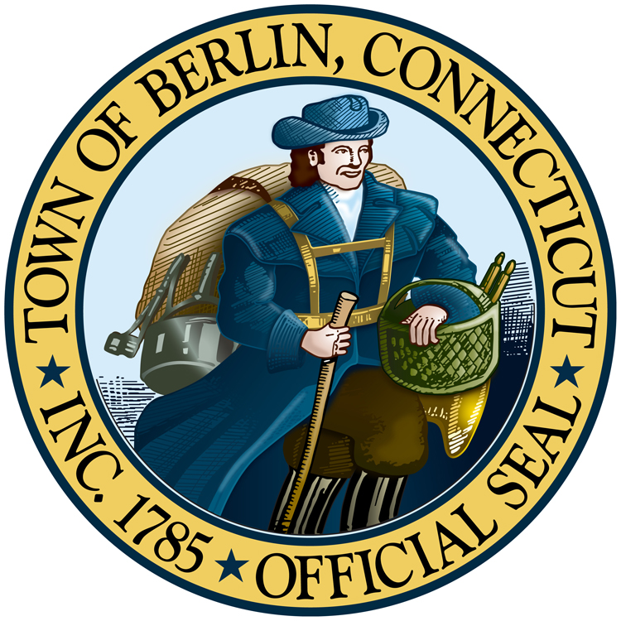
TOWN OF BERLIN

Office of the Mayor

TOWN HALL • BERLIN, CT 06037

Mayor Deputy Mayor
Mark H. Kaczynski Charles R. Paonessa

PROCLAMATION
WHEREAS, the 250th anniversary of the signing of the Declaration of Independence and the formation of the United States of America will occur on July 4, 2026; and

WHEREAS, Berlin founded in 1785 has contributed proudly and significantly to the history of our nation and our state for more than 240 years; and

WHEREAS, in 2016 the United States Congress established by Joint Resolution the America 250 Commission to encourage observance of the 250 years of our nation’s existence; and

WHEREAS, the Governor established Connecticut’s Semi quincentennial Commission with Executive Order 22-02, and the Commission has determined its mission and purpose is to develop, encourage, and execute an inclusive celebration, commemoration, and observance of the 250th anniversary of the Declaration of Independence through civic, cultural, and historical education events and programming; and

WHEREAS, the Commission will enhance tourism, economic development, history and civic education, historic preservation, and outdoor recreation within the state; and

WHEREAS, America 250 | CT will engage Connecticut residents in all 169 municipalities through local 250th committees and affiliate organizations through its culmination in 2028; and

WHEREAS, preserving, studying, and enjoying state history strengthens communities, builds pride, and forges bonds between Connecticut residents as we work together toward the goal of equality, and recognition of the unalienable rights of life, liberty, and the pursuit of happiness; and

WHEREAS, it is appropriate that Berlin engages fully with our past and looks toward a shared future; and

WHEREAS, the Mayor and Town Council of Berlin thus encourage its citizens to create and participate in programs that will commemorate the history of our town, our state, and our nation; and

NOW, THEREFORE, be it resolved that I, Mayor Mark Kaczynski, do hereby proclaim that Berlin will fully engage in commemorative activities leading up to and through July 4, 2026. I urge all community members to take advantage of the resources available from the America 250 Commission, the Connecticut Semi quincentennial Commission, and the Town Berlin to observe the 250th anniversary of the signing of the Declaration of Independence by coordinating commemorative events, planning historical activities, providing opportunities for public discourse, creating new scholarship around Connecticut’s complete history, creating new educational opportunities, and by seeking opportunities for historic preservation. Berlin pledges to uplift, support, and generate commemorative opportunities.

PROCLAIMED this 22nd day of July, 2025

______________________
Mark H. Kaczynski, Mayor

