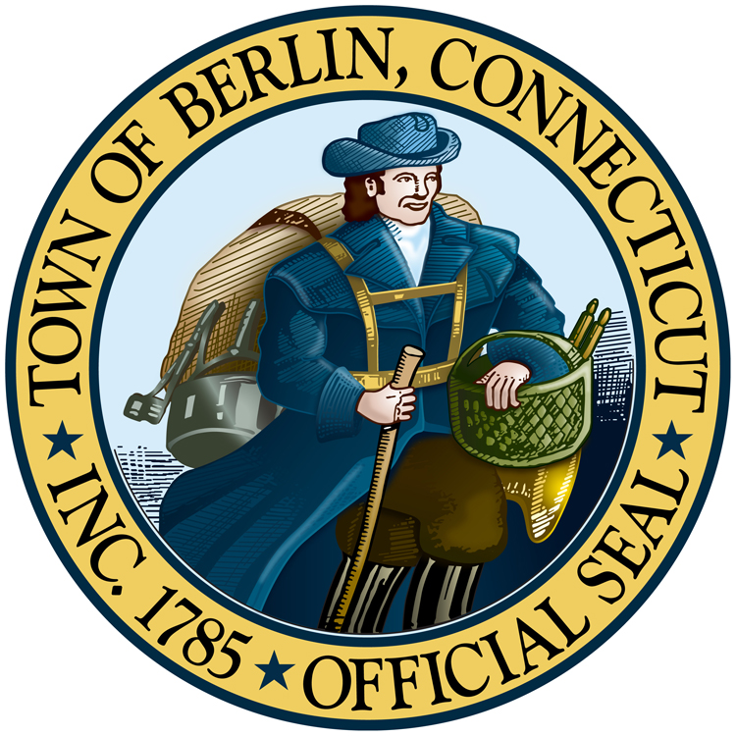
May 1, 2025

T o w n O f B e r l i n

Office Of the Town Manager
Update on Bright Feeds’ Efforts to Address Odor and Noise Concerns in Berlin, CT
On Wednesday, April 30, Mayor Mark and the Town Council held a public information session to provide an update on ongoing efforts to mitigate odor and noise issues at the Bright Feeds facility in Berlin. Bright Feeds CEO, Jonathan Fife, attended the meeting and outlined the steps the company has taken to address these concerns.

Odor Mitigation: In mid-April, Bright Feeds completed the installation of a Regenerative Thermal Oxidizer (RTO). The installation was observed by representatives from the Connecticut Department of Energy and Environmental Protection (DEEP). Since becoming fully operational, the RTO has reduced particulate emissions from the facility by approximately 98%. As a result, the offensive odors previously reported by residents have significantly diminished. The Town, in coordination with state agencies, will continue to monitor air quality and odor levels, but at this time, the situation appears to be substantially improved.

Noise Mitigation: To address ongoing noise complaints from Bright Feeds, the Town retained SH Acoustics, a sound engineering firm, to conduct comprehensive testing. While their initial analysis found that Bright Feeds was compliant with the Town’s noise ordinance during daytime hours, they would not be under the stricter nighttime regulations. Based on these findings Bright Feeds implemented a series of noise-reduction measures, including the installation of sound blankets, custom wool insulation on pipes, and silencers on multiple nozzles throughout the facility.

Following these improvements, SH Acoustics conducted follow-up testing on April 28, 2025, and confirmed that the facility is now fully compliant with the Town of Berlin’s noise ordinance during both daytime and nighttime hours. The full report is available here. Town and state officials will continue to monitor noise levels, but current data suggests the issue has been effectively addressed.

Next Steps: The Connecticut Department of Public Health (DPH) and DEEP are currently analyzing dryer stack emissions data collected prior to the RTO installation in January. This analysis will support a human health risk assessment. Once the testing results are available and analyzed, the results will be made public. DPH has committed to hosting a public meeting to review the findings with the community.

Bright Feeds continues to work with the Town, and state agencies toward a full resolution. The company has reaffirmed its commitment to addressing community concerns and appreciates residents' continued patience and engagement.

