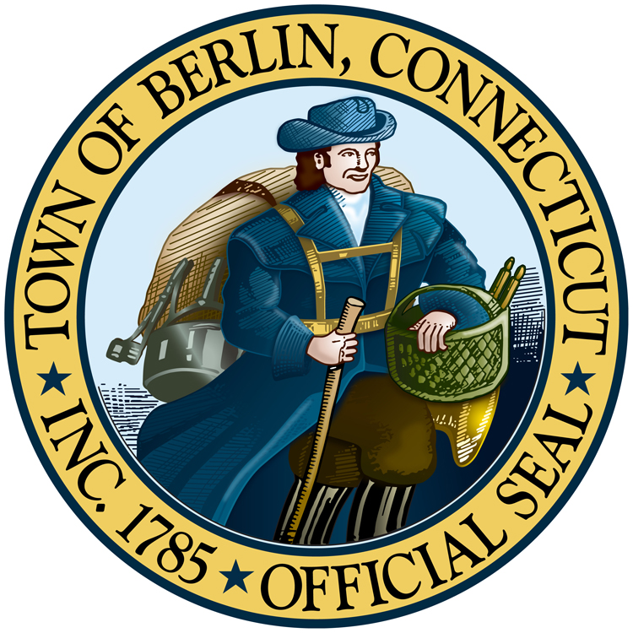
Berlin Parks and Recreation Pool Pass/Swim Lesson/Swim Team Registration Form
230 Kensington Road, Berlin, CT 06037 Office 860-828-7009
Primary Household Contact Information

First Name__________________________________ Last name_____________________________________________
Address_____________________________________ Apt./Box #______ Town__________________ Zip____________
Home # ( )_________________ Cell # ( )________________ Work ( )__________________________
Email Address_____________________________________________________________________________________
Emergency Contact___________________________Relationship____________________ Phone # ( )__________
If there are any special circumstances or health concerns of any participant(s) (medications, allergies, bee stings, seizures etc.) Department staff and contractual staff will not administer any medications except epi- pen for children 16 years of age and younger upon a written request accompanied by a parents written authorization and a written order of a physician, physician assistant or advanced practice registered nurse. The Department will accommodate as many requests as possible to the extent it can be done with reasonable control and safety. Forms to be completed for authorization are available at the Berlin Parks and Recreation Department. Please list here:
Pool Pass and Swim Program Information – List everyone in household who is getting a pass
__________________________________________________________________________________________________________________
First & Last Name M/F DOB Grade just Pool Pass Program # Program Name
Completed given

Release Agreement Please Read Carefully and Sign Below

THIS IS AN AGREEMENT FOR RELEASE, ASSUMPTION OF RISKS, CONSENT TO MEDICAL TREATMENT AND INDEMNIFICATION. IT AFFECTS YOUR LEGAL RIGHTS. YOU SHOULD READ IT CAREFULLY. In consideration of my participation in the Town of Berlin Parks and Recreation Program (the
Program”), _________________________, __________________________, ________________________, ________________________, _______________________, _________________________, ________________________________ (the “Participant”) individually and/or by my Parent or Legal Guardian (either or both herein referred to as the “Releaser”), on behalf of Participant, and Participant’s heirs and legal representatives, hereby releases the Town of Berlin, its officers, employees, agents and administrators from all loss of property, liability for injury, claims, causes of action, agreements, promises, damages, judgments whatsoever, which the Participant has or shall have, arising out of or related to participation in the Program and use of the equipment and facilities of the Town of Berlin and its vendors. Releaser is aware that there are risks and danger of personal injury and loss of property from participation in the Program, and Releaser acknowledges that participation in the Program is strictly voluntary and at Participant’s sole risk. Releaser hereby gives consent and permission to the Town of Berlin to obtain on Participant’s behalf emergency medical treatment in case of sickness, accident, or injury and to secure such medical attention at Participant’s expense. Releaser further agrees on behalf of Participant, Participant’s heirs and legal representatives to indemnify, hold harmless and defend the Town of Berlin, its officers, employees, agents and administrators from and against and in respect of any loss of property, liability for injury, claims, causes of action, agreements, loss, damages, judgments, costs, expense and attorneys fees whatsoever in connection with or arising out of Participant’s involvement or participation in the Program. The Parks and Recreation Department reserves the right to photograph program participants for publicity purposes. Please be aware That these photos are for Parks and Recreation use only and may be used in future brochures, flyers, website and/or on the Department bulletin board, located in the Parks and Recreation Department office. IN WITNESS WHEREOF, the undersigned certifies that he/she has read this Agreement discussed it with Town of Berlin staff and has voluntarily executed this Agreement on the day of , 2025

SIGNATURE____________________________________________ DATE___________________________ Parent/Legal Guardian if under 18 years old, Participant

